HISTORY
Of the
CHURCH OF JESUS CHRIST OF LATTER DAY SAINTS
In
CENTRAL TEXAS

By

Frank McCullough, PhD
And
Norma McCullough
Barton Creek Ward
Austin Texas Oak Hills Stake

Copyrighted
April 2005

PRELUDE and ACKNOWLEDGEMENTS

This history of the Church in Central Texas cover the key developments of the Church from 1845 to approximately 1991 when the Austin Texas Oak Hills Stake was formed (the second stake organized in Austin). A few events later than 1991 are covered since their inclusion were necessary for the flow of events in the text.
A detailed history of the Austin Texas Oak Hills Stake prepared by Bill J. Cannaday is included in the Appendix. It is included with his permission, and our sincere expression of thanks.
Of course, it is not possible to prepare a document such as this without the contributions and support of many others. Our sincere thanks goes to our son Scott and our Mother, LaVerne Walsh, for their work in reading various drafts of the text and providing valuable suggestions and insight into many of the events reported herein and their significance. Our thanks are expressed to our son Mike and grandsons Ben and Justin for their technical assistance provided in developing the manuscript. Thanks are also given to Bill and Carlene Cannaday, Gary Robinson, and Dr. Randall Wright for their review and suggestions.
As a final statement, we dedicate this report to our children, grandchildren, and future descendants so they may understand and appreciate their ancestors and other members whose sacrifices, struggle, and love of the Gospel made it possible for them to enjoy the blessings of the Church.

Frank and Norma McCullough

PREFACE
INTRODUCTION
TEMPORAL HISTORY
THE FIRST SAINTS
Decision to Emigrate
Moving to Texas
The New Home in Texas
Wandering In the Hill Country
Concluding Comments on the Colony

EARLY CONVERTS
Outside Influences on Church Growth
Success in Proselyting
The Converts
Impact of the First Converts

THE FIRST ORGANIZATION
The Austin Branch
The Members

ORGANIZING THE CHURCH
The Houston Stake
San Antonio Stake

AUSTIN WARD
Leadership
Members
The Church and the University of Texas
Ward Farm
Controversial Issue – Move or Stay
Strategy Change for Fund Raising
Save Our Trees
The Parker Lane Building
Two Then Three Wards

OTHER BRANCHES IN CENTRAL TEXAS
Riverside Branch / Ward
San Marcos Branch / Ward
Kingsland Branch / Marble Falls Ward

STAKE (S) IN AUSTIN
Change in Plans
Recruiting Wards
Organizing the Austin Stake

SIGNIFICANT EVENTS
Starting the Seminary Program
Local Contributions to the Missionary Program
The Blood Sacrifices
The Extra Mile – Community Service
Recreation Areas

SPIRITUAL EVOLUTION

LOST OPPORTUNITY
Potential of the Hill Country
Lessons from the Failed Colony

MIGHTY CHANGE IN HEART
Characteristics of Growth
Why the Difference?
Promises from the Pulpit

REFERENCES

APPENDICIES

A – LONG TERM LEADERS IN CENTRAL TEXAS

HISTORY OF THE CHURCH
IN
CENTRAL TEXAS

PREFACE
When one pauses to characterize the scriptures we all love to study and teach from, we recognize they are a record of God’s secular and spiritual dealings with his people. When they were obedient to his commandments, they were blessed spiritually and temporally. When they were less diligent, their problems increased and blessings decreased proportionally. In every family, community, ward and stake, these same trends occur over time. Unfortunately, few people stop to reflect on their history or connect the significance of events through time. Adding to the problem is the fact, that with our modern mobile society, most members only see a short window of time in the total history of a group. Hence, they seldom recognize that the spiritual and temporal status at any point in time is directly related to their cumulative obedience or disobedience over a much greater period of time.
Fortunately, the author having traveled to almost every continent in the world, has been blessed to live in Austin for all but two of his 71 years. For 55 years of that time, he has been associated with the Church. During this time he was either in history’s shadow or a direct participant in the decisions and events that shaped the Church in Central Texas. It is from this perspective by which he will convey his recognition of the historical axiom “whom and what we are is the cumulative product of our obedience and dedication over time”.

INTRODUCTION
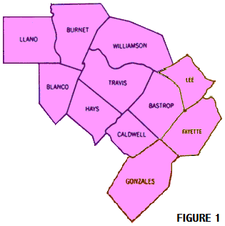
This text examines the historical spiritual and temporal evolution and historical development of the Church of Jesus Christ of Latter Day Saints in the Central Texas area from the 1840’s when the Saints first came to Austin to the present. The scope from an area standpoint covers the boundaries of the original Austin Branch followed by the Austin Ward. This encompasses an eleven county area that includes all or part of the following counties: Travis, Bastrop, Lee, Fayette, Caldwell, Gonzales, Hays, Blanco, Burnet, Llano, and Williamson [See Figure 1]. The baseline of this project is parallel ancient and modern scripture with the history of the Saints in this area to demonstrate, just as the scriptures have documented throughout history, that when The Lord’s People were obedient and faithful they prospered, and when they fell short of their capabilities their growth was limited. The focus is on the significance of the event and the roles individuals played in them. It is not intended to provide a record of all the individuals and leaders involved over the years. (Ref 1)
First, the temporal evolution is examined that covers the events, the organization of the Church and to some extent the people. Next, the spiritual evolution of the people recognizes when the Saints did not follow the counsel of the Lord as revealed by the prophets, the Saints struggled and ceased to exist as organization. Then later, when the Saints followed the counsel of the Lord, the Church experienced growth and prosperity.
TEMPORAL HISTORY
When considering the history of the Austin Area, one should recognize that the present members of the Church of Jesus Christ of Latter Day Saints in Austin are not “Johnnie Come Lately’s”. They can state with humility and dignity that they belong here since their roots and heritage are an integral part of the community. Some members trace their ancestry to the start of the Republic of Texas starting with a survivor of the Goliad Massacre, a participant in the Battle of San Jacinto, and the original German Settlements in Central Texas. The Saints were here near the time of the original founding of the city and left their mark, faded away for a generation, with missionaries eventually returning and many converts being baptized in the rural areas around Austin. Soon a branch was formed followed by a ward, then a stake, and finally three stakes in the area. Today, thanks to those who preceded the current generation, the local saints are a vibrant and respected part of the community. The following sections provide a history of the first saints, the missionary period, the first formal organization – a branch, the evolution from one ward to three stakes, descriptions of significant events, and finally a short discussion of non members in the area that played key roles in the Johnston Army Episode of Church History.

THE FIRST SAINTS
To fully understand the time perspective, it is recognized that approximately 25 years before the great longhorn trail drives that came through Austin, starting in South Texas and ending in Kansas, the Saints were here. Only six years after the City of Austin was formed, members of the Church moved from east of Austin to the western edge of the city to form a community. Furthermore, in 1846, one year before the Saints started laying out the streets of Salt Lake City in 1847, the Saints in Austin were clearing the right-of-way for streets at the western edge of the city. Modern thoroughfares currently utilized by thousands of vehicles per day such as Far West Boulevard, Spicewood Springs Road, Scenic Drive Road, and Exposition Boulevard were started by the Saints.

Decision to Emigrate
Considering the main body of the Church was in Nauvoo, Illinois, the presence of the Saints in Austin was unusual. Their presence in Austin had its’ roots in the desire of the Church Councils, looking for a way and/or location, to establish a degree of political and legal independence. During this period in the early 1840's, they were considering sites in Texas, California, Oregon, and Utah. (Ref 2) In September of 1843, Brother Lucian Woodworth returned to Nauvoo and reported to President Joseph Smith encouraging news from the south. He reported Texas was an ideal place to make their home, and he believed land could be purchased west of Austin. (Ref 3) During consideration of these different locations, Lyman Wight, an apostle and companion of Joseph Smith in the Liberty Jail, submitted a request in March of 1844 that the Pine Company be permitted to emigrate to Texas. At that time, they were in Black River Falls, Wisconsin providing timber for the development of Nauvoo by floating it down the Mississippi River. Now they desired to provide another step in developing the Kingdom as expressed in his letter.
“…we have in our minds to go to the table lands of Texas, to a point we may find to the most eligible, there locate, and let it be a place of gathering for the entire South.” (Ref 4)
The proposal was basically accepted when the Prophet Joseph Smith requested the Pine Company to return to Nauvoo with their families. They arrived on March 8, 1844 and started making preparations as they waited for spring. The proposal was reconfirmed on May 6, 1844 by the Prophet Joseph Smith during a meeting of the General Council (Council of Fifty).

“Let George Miller and Lyman Wight take the Black River Company and their friends and go to Texas … to intercede for a tract of country which we the Church
might have control over, that we might find a resting place for a season.” (Ref 5)

Lyman Wight later explained the purpose of the Texas Mission.

“This instruction was given me by Brother Joseph Smith with great zeal, setting forth the necessity of such a mission for the good of the cause of bringing the Lamanites to the knowledge of the truth, paving the way for the redemption of Zion and building the Temple in Jackson County, and giving our posterity inheritances.” (Ref 5)

After the martyrdom of Joseph Smith, even with the increased local persecution in Nauvoo, The Twelve Apostles met in council on August 12, 1844, and resolved that Lyman Wight go to Texas with his company if they so desired. In the October, 1844 and April, 1845 General Conferences, Lyman Wight continued to be sustained as an apostle. After further reflection, Brigham Young in a letter to the group dated April 17, 1845 offered the following significant counsel that prove to be a prophesy for the colony:

“…If you go westward before you have received your endowments in the Temple
you will not prosper. And when you meet with trouble and difficulty…” (Ref 6)

Contrary to the warning, the group decided to leave in May 1845 before their endowments were received since the Temple would not be completed sufficiently for endowment sessions until the late Fall. This late departure date meant waiting until the following spring since they needed to arrive before the winter months started in order to have sufficient foliage for their animals. This would have meant a two year delay from their first approval. Furthermore, since they were traveling through a thinly populated land in what is now Iowa, Kansas and Oklahoma, there was very little protection from the elements or opportunities to replenish their supplies. Anxious to start on a new adventure and with only an “earthly perspective”, the decision to go on without their endowments appeared to be the logical course of action. It is only with “20-20 hindsight” of the subsequent events, and a clearer understanding of the endowments, do we recognize that the path to failure had been set.

Moving To Texas
The company started with 164 people and experienced nine deaths on the trail prior to arriving at Fort Johnson near the present city of Sherman, Texas after traveling 1,130 miles in 229 days. They wintered here and after recovering from their long and dangerous journey, they left on April 26, 1846 for the final 230 miles to Austin, Texas. The Saints arrived approximately 15 miles east of Austin on June 6, 1846 and set up camp at Webbers Prairie – now the community of Webberville [See Figure 2].
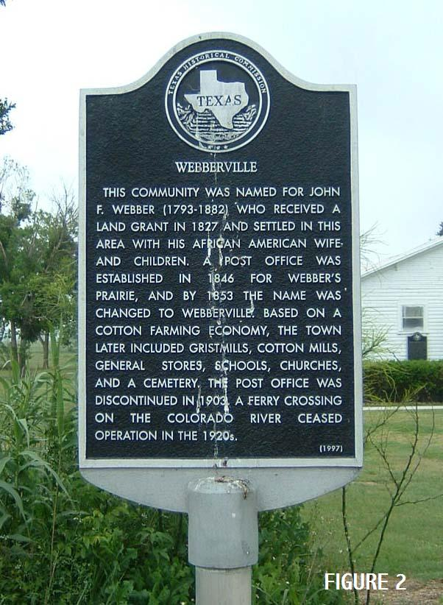
It is interesting to compare the Lyman Wight Saint’s trek to Texas with the Pioneer’s trek to the Salt Lake Valley. As to distance, the journeys were very similar with approximate distances of 1400 miles to Austin, Texas and 1500 miles to the Salt Lake Valley. Both groups spent a winter replenishing for the last leg of the journey with the Wight Group near Sherman, Texas and the Pioneers at Winter Quarters, Iowa. The Pioneers had to make the formidable climb over the Rockies near the end of their journey and cross Iowa during a cold wet winter, whereas the Wight Group had to cross seven major rivers, but with a much milder winter. The death rate for the Wight Group was only five percent where the Pioneers experienced 20-25% during their journey. In the short term perspective of minimizing problems, the decision of the Wight Group to leave without their endowments appeared to be the correct one, but the long term impact of ignoring spiritual counsel would prove to be devastating to the colony.

The New Home in Texas
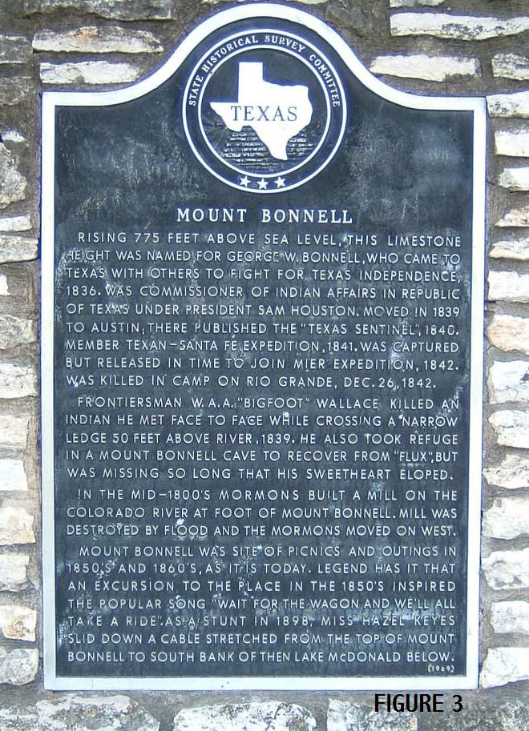
After Lyman Wight traded a pony for 160 acres of land, the Saints moved to the base of what is now Mt. Bonnell at the western edge of Austin, where a large spring was located [See Figure 3]. The springs became known as Mormon Springs, so named by the locals after the Saints settled there. The Company was duly impressed with the beauty of their new home. The Texas Hill Country provides numerous pastoral settings and the Company was impressed by their view of the hills with its’ numerous springs and streams and the Colorado River winding through it with fertile valleys on both sides of the river. The site was later covered with water due to the construction of a dam and the subsequent formation of Lake Austin in the 1930s. Here they set up a mill and the first grain was produced on July 30, 1846 only 1 ½ months after their arrival. Since the location was approximately four miles upstream from Austin with an overland journey through very rough terrain laden with Juniper and Oak trees, it was necessary to establish and construct the road system mentioned previously.
Since the Saints were experienced in construction and there was a great need to generate cash, the Saints entered into a contract to build the first jail in Austin for $1800. The location was on the north side of 3rd Street between Guadalupe and San Antonio Streets in what was then the City’s First Ward. This event is commemorated by a historical marker on the lawn of the current Travis County Court House at 10th and Guadalupe Streets in the downtown area [See Figure 4].
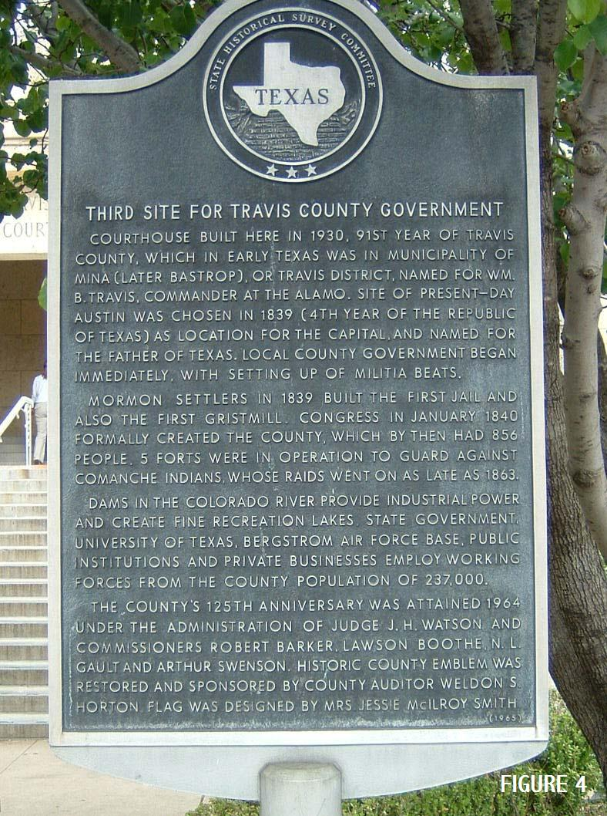
The Saints were a welcome addition to the community since their location on the western side of the city served as a buffer between Austin and the Comanche Indians to the west. The Comanche’s were notorious for their murder and plundering of small groups, and problems were experienced near Austin as late as 1867. Several years earlier Sam Houston, while President of the Republic of Texas, had negotiated with the Saints in Nauvoo to move to the Hill Country west of Austin to provide a presence between residents of Austin and the Indians.
In general, the Saints were welcome with no evidence of trouble or persecution. Naturally, they were viewed with some suspicion since their numbers of 160 (+) outside of what was then a village of 800 to 1000 people represented 15 to 20% of the population. Still, they moved freely about the city and Lyman Wight preached a sermon from the capitol grounds.
In October 1846, the spring furnishing power to the mill ceased to flow and they immediately started to look for a new site. Springs drying up are a common occurrence in the Hill Country after a dry summer unless it is supplied by a large source of water such as the Edwards Aquifer, which basically constitutes an underground lake of sorts. In another of successive steps fulfilling Brigham Young’s prophecy of the colony’s future the group looked for another site and turned their back on the infrastructure they had produced –roads, mill, houses, etc and the goodwill with the city to start another adventure. The Austin mill site was sold for 300 head of cattle, and by September 24, 1847 – one month after the Pioneers reached the Salt Lake Valley – the entire colony left Austin moving further west into the Hill Country. Part of the group had left earlier for another site in the Hill Country.

Wandering in the Hill Country
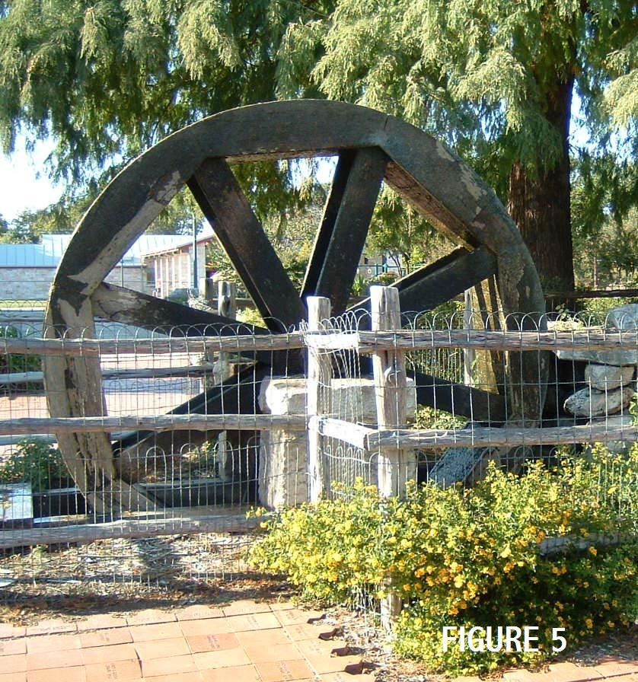
A mill was started on Grape Creek after an interim stop, about 12 miles east of Fredericksburg, but the spring there also dried up. The group next constructed a mill and village about 5 miles east of Fredericksburg on the Pedernales River. Several buildings were constructed including a storehouse with an upper story, serving dual usage as a school and a religious room. The local Germans referred to it as the “Mormon Temple”. During this period, they practiced anointing and baptism for the dead. (Ref 3) In addition, the community had a blacksmith and woodworking shop, as well as a number of well constructed homes. The community was named Zodiac. The Saints were prosperous with considerable property, material goods and respect from others in the area. The local Germans and the military located at Fort Scott just out of Fredericksburg provided an ample outlet for their goods and services.
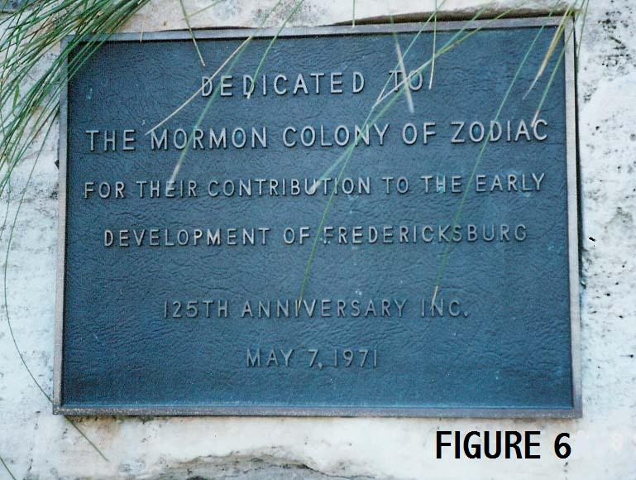
When the Saints first arrived in the area the German immigrants in the Fredericksburg area were very short on food and fast approaching a state of starvation. The Saints provided them with freshly ground cornmeal from their mill. In addition, the German immigrants were new to this country and unfamiliar with the crops so the Saints taught them the type and manner of growing crops in the new land. Basically, the generosity of the Saints was instrumental in saving the German colony from starvation. Since that time, the Germans have never forgotten the Saints act of kindness, and their role in saving the German Colony from starvation. In 1972, during a major celebration for the 125th anniversary of the town, the citizens of Fredericksburg dedicated a waterwheel to the Mormons in appreciation of their generosity. A member of the Presiding Bishopric accepted the monument of appreciation on behalf of the Church. The Waterwheel Monument is still located in the town park across the street from the City Library and is open to all visitors [See Figure 5, 6].
During mid June of 1850, a flash flood, typical of those experienced in the Texas Hill Country hit Zodiac, destroying the mill and doing additional damage to the town and crops. After a three day fast, Lyman announced he had been instructed in a vision to rebuild the mill. This task was accomplished and the mill was operating within a month. Another flood hit in February 1851 destroying the mill and washing away the burr stones used to grind the corn. An exploration party was then sent out to locate another site and shortly thereafter, they abandoned their site rather than make the necessary repairs. The site where the City of Zodiac was located is currently marked by a state historical marker in a cultivated field. No evidence of the town exists today, but the site may be visited by turning left on a county road about 3 miles SE of Fredericksburg on US 290 [See Figure 7].
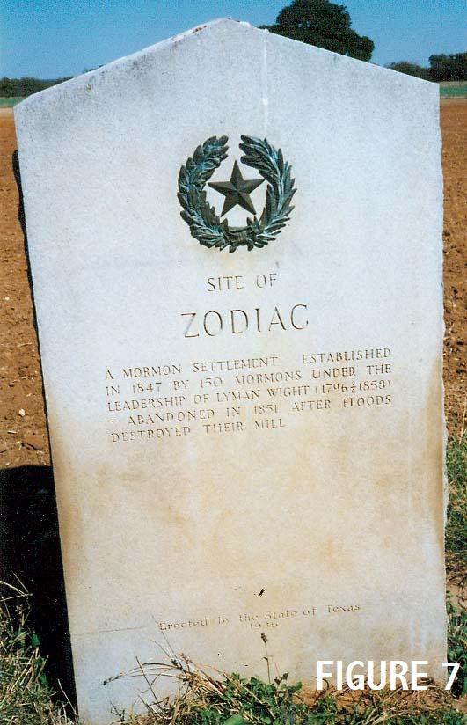
In mid-summer 1851, the Saints constructed a gristmill on Hamilton Creek northeast of the present city of Marble Falls, and they also established a new settlement called Hamilton Valley that was later renamed Mormon Mill. The gristmill required millstones and after a three day period of fasting and prayer, Lyman guided the followers to a sand bar in the Pedernales River downstream from Zodiac. Here he directed them to dig and after removing a few feet of sand, they found the millstones from the destroyed mill and took them to the new site. Unfortunately, the soils in the creek bottom around the new home sites were shallow and much more appropriate for raising cattle, as it now used, than for growing crops. Hence, although the site was free from flooding, the crops were poor and there was a limited market for the products. Fort Croghan, another in the series of protective forts, was located approximately 8 miles northwest of Mormon Mill and did not have an adjacent settlement similar to Fredericksburg to provide the necessary commerce [See Figure 8, 9].
In the fall of 1853, the colony was on the move again, stopping for a short time on Honey Creek southeast of the present city of Llano. Continuing on after the stop at Honey Creek and brief respites at various sites in the Hill Country, the Saints started building a mill at a site on the Medina River and making shingles to sell near the present town of Bandera on March 1, 1854. At the end of 1857, Lyman declared that the mission in Texas was over, and it was time for them to move north once again. On March 31, 1858 during the first stage of their move north, Lyman Wight passed away, and he was buried in the cemetery on the Pedernales near the Zodiac town site.
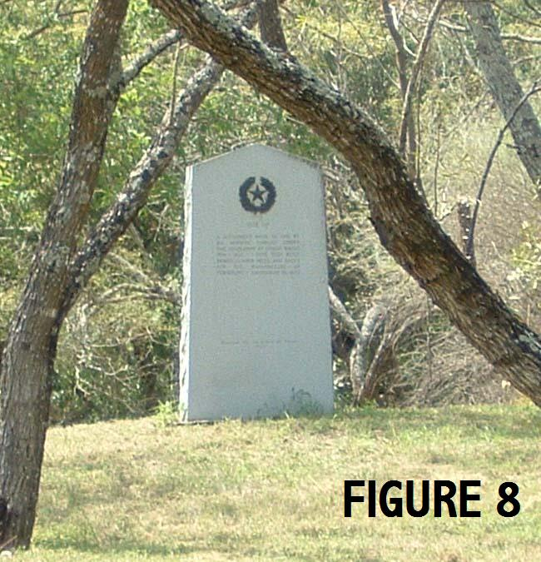
Lyman Wight’s mission in Texas and his leadership, as is the case with all strong leaders, provides a contrast in perspectives. From a spiritual standpoint, he had demonstrated the strength of his faith and prayers by guiding the members to the location of the mill stones lost when Zodiac was flooded by the Pedernales River. The event certainly had miraculous implications as documented by a noted Texas pioneer and historian.

“…Old Lyman, the High Priest, set about the task of recovering the stones…in the middle of a sand bar, he instructed to dig right here…his followers never doubting, started to dig …the stones were recovered.” (Ref 7)

Understandably, the Gentiles usually viewed the group with suspicion, as the Mormon settlers were very tightly knit. Yet a positive perception of the group was documented many times, such as the article by Frank Brown in his “Annals of Travis County”.
“…The colony produced a good impression upon other peoples. They were known for their thrifty habits and their inoffensive and law abiding disposition…, and their conduct was worthy of imitation.” (Ref 8)

Yet some observers of the colony felt their accomplishments were achieved at a price.
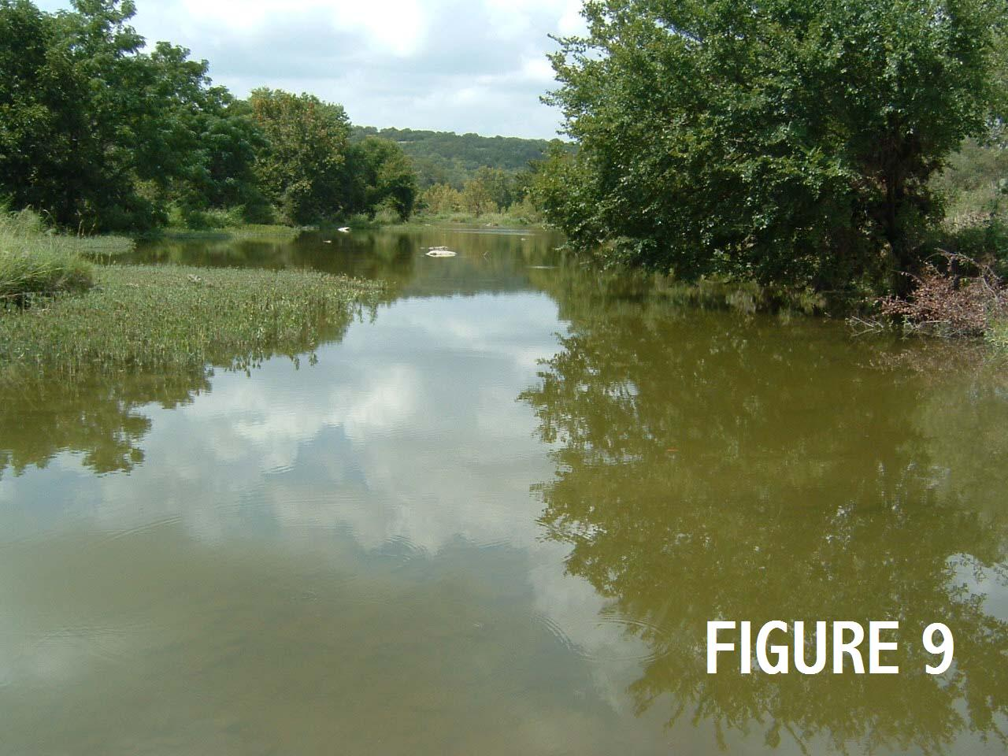
“… organizer and leader, Lyman Wight enjoyed a complete dictatorship. Property was placed in common stock and held in his name. His dominant personality kept the group together.” (Ref 9)

Because Lyman Wight’s strong personality created a void of future leaders and the removal of the group from the rolls of the Church and the corresponding lack of guidance from the First Presidency, there was no apparent successor and the group was without direction. Almost 12 years after the group had arrived in Central Texas with so much promise, the group dissolved, with a portion of them going on to Utah to join the pioneers and others simply absorbing into the general population.

Concluding Commentary on the Colony
Reflecting on the merits of the colony 147 years later, one sees both the positive and negative aspects of their adventure. On the positive side, the group was the founders or co-founders of three counties in Texas i.e. Gillespie, Burnet, and Bandera. In each of these areas, they were a vibrant community, contributing to economic development, as many of them were skilled craftsmen, and in one case instrumental in saving another colony. They left their lasting marks on the land, such as a street system in a section of Austin, buildings, names on sites such as Mormon Mill, etc. They were good examples and neighbors in the community, furnished excellent craftsman and evidently provided a Christ-like example of living to all.
On the negative side, the colony failed, as reflected in it’s wandering over the hills, lack of stability and finally dissolution while considering its’ initial goal of providing a stable colony for the Church. The final results were a ringing fulfillment of the prophecy by Brigham Young.

EARLY CONVERTS
The failure of the Lyman Wight Colony and the political upheaval in the United States resulted in an approximate 35 year absence of the Saints in Central Texas. The before and after periods are substantially different from one another with the first being a colonization, and the later period using converts to increase their numbers. These evolutionary factors reshaped the role of the Church in Central Texas, thus they are discussed along with identifying early converts, reflecting finally on what has occurred with approximately 100 years of history behind us.

Outside Influences on Church Growth
Shortly after Lyman Wight passed away, the political and philosophical differences between the northern and southern states that had festered since the 1830’s became more emotional and contentious. The differences became more focused in 1860 with the election of President Abraham Lincoln. Eleven states, including Texas, dissolved their ties with the Union and formed the Confederate States of America. Shortly thereafter, in April 1861, the War Between the States started when the Confederate States fired on Fort Sumter, South Carolina. The significance of this event relative to the Church was that within the war and reconstruction time framework, there was a 16 year period from 1860 – 1876 that was not conducive or safe for missionary work. This, combined with the merging of the Lyman Wight Saints into the general population and their minimal missionary work, the Church and its teachings for all practical purposes ceased to exist in Central Texas.
The presence of the Church in terms of missionary work started to reappear in the more populous southern states to the east of Texas in early 1880s. Unfortunately, Texas was on the outer extremities of four missions that served the area from 1875 to 1930 with the Mission Offices being in Tennessee, Georgia, Kansas, and Missouri. In June 1894, Elders Jens Hansen and John K. Nicholson, both of Salt Lake City, were sent to open the Texas Conference (Area). (Ref 10)

Success in Proselyting
By 1896, the missionaries had worked their way into Central Texas and experienced their greatest success in Texas during this period. During the five year timeframe from 1896 to 1900, there were 115 baptisms recorded in the Central Texas Counties (referred to as The Austin Conference in Church records). Table 1 presents a distribution of the communities where the baptisms occurred over the five year period. It is interesting to note that 74 of the 115 baptisms occurred in a 30 x 30 x 30 mile triangle comprised of Jeddo (Bastrop). Waelder (Gonzales), and Lockhart (Caldwell) counties. Also note that only 3 baptisms were performed within the city of Austin and it’s immediate outlying areas . By 1901, there were 141 baptized members and 64 children of record listed in Central Texas. (Ref 10)
The rural areas were more productive than the larger cities since farmers were much more independent and self sufficient. The Elders represented independence, courage and stamina thus they were respected and cared for by most country people. In stark contrast with the cities, people in the country did not have to worry about what their neighbors would think of a visit from the local minister if they chose to hear the missionary’s message. Furthermore, rural Texans have always been a friendly people (Texas’s motto is the Friendly State) so a visit by anyone was a welcomed experience for people having very little outside human contact during the week. These factors created an atmosphere much more receptive for missionaries teaching the gospel.
The interaction pattern between the elders and the people was always generally the same. Each time they visited an area, the elders would baptize an individual or family, then hold meetings with them in their homes on subsequent visits. The new converts would share the message with their relatives or friends and the process would be repeated. In examining the first five years of convert data, it was common to see the same surname show up on the list many times.
The converts were scattered over a wide area and there were few local priesthood holders so members depended on the missionaries to occasionally come and hold meetings, bless the children, baptize, receive tithes and offerings, and provide leadership, counsel, and direction. Occasionally there would be a gathering of all the members in the Austin Conference. The saints attended in wagon and on horseback, bringing food, utensils, bedding and tents. They would then spend several days listening to the messages and enjoying one another’s company.

The Converts
The earliest recorded baptisms were in August and September of 1896, when 10 members of the Petty Family and 5 members of the Roach Family of Lockhart in Caldwell County were baptized along with a member in rural Caldwell County and a sister from Wimberley in Hays County. In November of 1896, 10 members of 6 families were baptized in Bastrop. Additionally, in November of 1896, the first 3 recorded baptisms in Austin were a mother, Eugenie Thomson and, two teenage daughters, Endora and Sophia Thomson. Of the 36 baptisms in 1896, they ranged in age from 9 to 66 years and of those, 9 were teenagers. Table 2 lists the converts in the first year of 1896. Note, there are 13 surnames represented, but most are from several families. The baptisms in the four subsequent years of 1897 – 1900 follow a similar pattern. Most all of these baptisms followed the pattern of families in rural areas sharing the gospel.
Preserved by the descendants of one of these early converts, one conversion story unfolded when Elders Hansen and Chidester were tracting in Jeddo in Bastrop County and they stopped at the home of August and Mary Ann Coquat for a drink of water and an opportunity to give a message. The story had been circulating that the Mormon Elders had come from Utah to take all the young girls back to Utah for plural wives. Mary Ann first placed her two daughters Mary Ann Minerva and Fannie Elizabeth in a back room for safety, then met the Elders at the door with an ax. Needless to say, the Elders did not get a drink of water nor deliver their message. Later Augusta Coquat, the family father, heard the Elders preach at the local school and came home with an enthusiasm for the Gospel. Shortly thereafter, Augusta and his wife, two daughters, and son joined the Church in 1896 and 1897.

Impact of the First Converts
Unfortunately, this loose knit organization did not prove to be too productive in the long term. In some cases, the death of a leader of a small group would be devastating due to lack of a replacement, and subsequent lost direction. In other cases, the converts were mentally “tied’ to the missionary and when the missionary was released, the individual enthusiasm of the convert for the gospel faded. Furthermore, with the absence of organizations such as Relief Society, Primary, MIA and Priesthood, the sense of brother or sisterhood could not be developed nor strength gained or realized from sustaining one another. Consequently, the next generation lost their identification with the gospel and faded from the church rolls into society. Others moved from the rural area to the larger cities as was the trend in the first half of the 20th Century or occasionally joined the “gathering of the Saints” in Utah. Considering the obstacles faced by the early converts and the failures of the Lyman Wight colony of Saints, the present membership owes a debt of gratitude to those coming before for sustaining the Church during the challenging and difficult early years.
The long term impact is very evident in Central Texas. Of the 115 Central Texas converts from 1896 to 1900, only the line of Fannie Coquat has remained active in the Church. As of the present time there are approximately 60 descendants active in the three current Austin Stakes represented by the Walsh, Jackson, McCullough, Cannaday, Allison, Boyd, Bateman, Grayson, Moccia, Pearson, and Sanders families. This group has produced five Bishops and served in countless other positions in the Stakes. This one line of descendants has been supportive and productive over the past 100 years to the stakes in Austin, although one wonders how much faster the growth of the Church in Central Texas would have been if 1/4th or 1/3rd of the list of converts would have continued active in the church from that time to the present.

THE FIRST ORGANIZATION
During the first four decades of the 20th Century, the Church development in Central Texas followed the population pattern shifts of the United States in general with the movement of people from the rural areas to the cities with Austin being the chief beneficiary in Central Texas. Correspondingly, the missionary efforts in the area followed the same pattern. Soon there were sufficient people for scheduling meetings in the homes of the members with the core of members residing in the City’s 10th Ward area of Austin, located east of IH 35 and south of East 1st Street (Cesar Chavez) to the river. In February of 1920, the first Sunday school was held at the old Graham Drug Store on the NW corner of 9th Street and Congress Avenue. (Ref 1) These developments led to the formation of a branch and a continued increase of the membership.

The Austin Branch
The Austin Branch was formed with approximately 30 members on December 3, 1924, and John Bremer was called as the first Branch President. He served in this capacity for two years and established an excellent foundation of leadership in the area because of his experience. President Bremer previously served for four years as the first Branch President of the San Antonio Branch. Albert Goldstein, a convert, served 12 years from 1928 to 1940. During his tenure the membership increased to 46 members. There were several branch presidents during World War II but many of their names have been lost. During this time, there were numerous periods when leadership of the branch reverted back to the Mission President due to the lack of leadership. The Church Archivist has identified several of the early Branch Presidents, some of which are Terrell Nelson, Andy Gonzales, and Elder Earl Blake as acting President. (Ref 11) After the war, Roy Watson was called as Branch President in 1946 and he served in that capacity until the Branch was made into a Ward in 1953 with 280 members.
After the Branch was organized, they met in various halls in the downtown area such as the Labor Temple (10th and Brazos), the Modern Woodman Hall on Congress Avenue, etc. These halls left much to be desired as a church meeting site since they were old, dingy, and inadequate. Many times a party had been held the night before and the smell of alcohol was strong. Primary and MIA were still held in the member’s homes. Norma McCullough and Carlene Cannaday recall having Primary on their front porches with the Sister Missionaries conducting the classes.
During this period the members dreamed of a “home” of their own and in 1940 a building fund became a reality and members agreed to donated a $1.00 a month or more. In addition, the Relief Society sisters voted to contribute 50 cents a month via fundraising efforts. By approximately 1948, the contributed funds plus the commitment of donated labor were sufficient to start construction on what was fondly known as “The Little Limestone Chapel’ at 3310 Red River Street near the University of Texas Campus [See Figure 10]. The cost of the building was approximately $40,000 with $8000 (20%) being the responsibility of the Branch. The chapel was dedicated on November 29, 1949 with Elder Joseph Fielding Smith (Acting President of the Twelve Apostles) presiding and Elder Bruce R. McConkie (Assistant to the Twelve) giving the dedicatory prayer. Sister Jessie Evans Smith accompanied her husband and delighted the congregation with a solo.
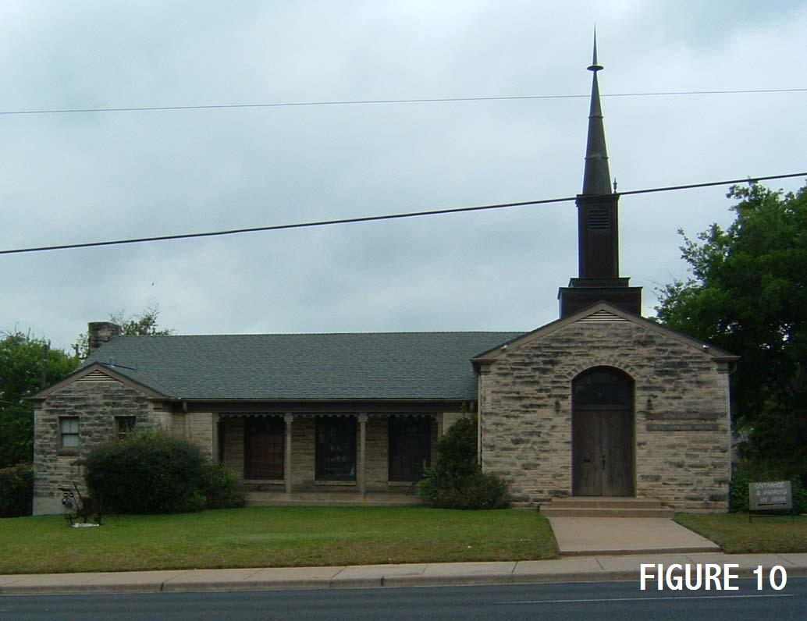
The chapel represented quite an achievement since the active membership numbered 50-60 individuals at the time. Much of the actual construction labor was performed by the members in order to pay off their building fund assessments. The Relief Society contributed their effort by furnishing meals to those working on the construction. The small ward quickly filled up the new chapel and on December 12, 1953, the Junior Sunday School building, a separate edifice behind the main church building, with about 2/3 of the floor area, was dedicated by Elder Mark E. Peterson, member of the Twelve Apostles, after being built primarily by donated labor in the same process as the chapel.
During this time period the Lord blessed the Branch with a man who was talented with his hands as well as organizing workers. This leadership experience was instrumental in constructing a building with a chapel, cultural hall, and Relief Society room, then later another large building for Primary, Junior Sunday School, and Aaronic Priesthood Classes. President Watson had served with the military in Austin where he married Mona Killough, a local member, and they chose to live in Austin after the War. In addition to his excellent leadership, he was a teacher in trades at Austin High School.
Since the membership was not affluent, extra funds were in short supply so the opportunity to pay off the local share of the building costs by assisting in the actual construction was a great blessing to the Branch. With very little cash funds, but plenty of faith, a willingness to do physical labor and experienced leadership, two church buildings were started, completed, and dedicated by a small congregation.

The Members
During the Branch’s evolution and development period, the membership increased by move-ins and conversions. The Coquat sisters married (Mary Ann Lundy and Fannie Walsh) and moved to Austin, where they raised large families. Jennie Reese Zimmerman, a lifelong member from England, moved to Austin and married Frederick Ernest Toburg in 1910.
Emery Bell of Nacogdoches joined the church in Austin on July 20, 1919. He and his wife were both blind and they moved to Austin to learn a trade at the Texas State School for the Blind. Church meetings were held at their home on East 2nd Street for a period of time. Brother Bell was advanced to Elder eleven months after he joined the church and he was an example of faith and self reliance. He was a counselor in the first Branch Presidency. They were without children.
Emmett and Jeffie Wilson were baptized on May 13, 1920, and their numerous children are represented on the rolls of the three current stakes in Austin.
Othella Brooks Greathouse was baptized on February 22, 1920 at the University of Texas YMCA. She was subjected to some harassment by her neighbors but was strong and faithful. She served as Relief Society President, teacher, and missionary. Her sister, Laura Mae Killough and LaVerne Walsh were baptized 20 years later in 1942 in the font of a local protestant church. Following the services, the minister of the church spoke to the group and denounced the church and ridiculed the Elders.
Albert and Emma Goldstein and their two sons joined the Church on June 18, 1922 in Austin. Albert was from Austin, Emma was from Sweden, and the boys were born in Kansas. Their descendants were numerous and are also on the rolls of the three stakes with many different surnames. Tempie Mason, Elsie May Halliburton Frederick and Rhoda Halliburton (sisters), Susan Hagle Chambers and Carolina Anderson Eckstrom were baptized in 1925 as were two children.
Others also became part of the nucleus of the branch. Joseph and Gertrude Gruenwald and their large family were present. Kalei O’laie Pollard came to Austin as a bride and was born in Hawaii where her parents worked for the Church. Her husband Cecil Pollard (PhD) was also a member and on the faculty at the University of Texas with a specialty in the Germanic Languages. Paul (M.D.) and Ruth Paris came to Austin in 1940 with their three children. Dr. Paris helped many members of the Branch with medical services and both were an anchor of faith. Brother Paris eventually served as the first Patriarch of the Austin Stake.
William Claude Ghormley (M.D.) came to Austin about 1940 with his wife Pearl, a non-member. After they separated, she later decided to investigate the Church to understand her husband’s dedication. She joined the church and was very active, serving as editor and publisher of various newspapers for the Branch, Ward, and the Houston Stake. Her newspapers have served as excellent documentation for many individuals conducting historical work about the Church in Central Texas. She was also prominent in the selection of the property for the Institute Building near The University of Texas campus.
Laverne Albers Walsh married Norman Walsh, son of Fannie (Walsh) Eckstrom, in 1931 and joined the church in 1942. During her 11 year investigation, she was a very active participant in the Branch serving in the MIA, Relief Society, etc. She was “active” for so long that most people, including the missionaries, assumed she was a member. In her words, “one day in 1942, the Holy Spirit whispered it was time to join the Church”. She followed the whisperings of the Spirit and has continued to be a stalwart in the Church, serving in a long list of Branch, Ward, and Stake positions. She has over 30 descendants active in the Austin Area with additional ones in other cities. At the age of 92 years in 2005, she is the senior member in Central Texas, still holding church positions and in regular attendance at all church meetings.

ORGANIZING THE CHURCH
Shortly after David O. McKay became President and Prophet of the Church, he visited Dallas to dedicate a new building. President Benjamin Bowering of the Texas-Louisiana Mission took a unique step from the administrative standpoint of the Church by stating “we should have two more Texas stakes in addition to the El Paso Stake”. Notification came two weeks later those two new stakes would be organized with the first being formed at the next Houston Conference on October 2, 1953. As a part of this conference, the Central Texas Area would be represented by the Austin Ward as part of the Houston Stake. On January 19, 1958, with a stake split the Austin Ward became a part of the San Antonio Stake.

Houston Stake
The new stake had 8 wards and 7 branches with approximately 3900 members and was organized by Elders Mark E. Petersen and Delbert Stapley of the Quorum of the Twelve. Jack Trunnell (MD) was called as the Stake President.
Most of the members of the Austin Ward had no understanding of what being a part of a stake entailed but were quickly introduced to the benefits and sacrifices required. First, the distance was approximately 170 miles to the Houston Stake Center over a road system much different from the one now used to go to the Houston Temple. This was prior to the Interstate Highway System and its use of divided highways. From Austin to Columbus was a two lane highway that required the traveler to go through the city centers of Bastrop, Smithville, LaGrange, Columbus and all the smaller towns in-between. From Columbus, the trip improved with a four lane highway for most of the remainder of the trip but it was necessary to go through the city centers of Sealy and Katy. Instead of the present 2½ hour trip to the Houston Temple, better than 4 hours each way were required for a trip to stake meetings.
During that time period Stake Conferences were scheduled on a quarterly basis with two hour meetings in the morning (10am-12 noon) and afternoon (2-4pm). Thus, a family going to Stake Conference had to leave Austin about 5:30am in the morning and would return to Austin about 9:00pm – a very long 15 1/2 hour day. Leadership meetings required a 10-12 hour day. For welfare service, the membership had to go to the Baytown Cannery which added another 3 hours to the trip. Conversely, the stake leaders had to make similar time and financial sacrifices since the ward Priesthood and Sunday School meetings were in the mornings and Sacrament meeting was in the late afternoon. The older members of the Austin Area can vividly recall the Stake High Councilman from Beaumont regularly coming to Austin to carry out his duties that required a 7 hour one-way trip, time for business, and a 7 hour return trip.
Although being part of a stake organization required a new level of sacrifice compared to being a Branch in the Mission, the blessings far exceeded the cost. First and foremost the spiritual educational progress of the members was rapidly accelerated. There was continuity of meetings and teaching opportunities rather than on an occasional basis, as was the case during the Early Convert and Branch stages of development. Members heard numerous individuals teach classes and deliver talks that provided a much wider perspective to learning and applying gospel principles in their lives. In addition, they had direct contact with the Council of the Twelve and Assistants during Stake Conferences.
The fellowship opportunities were widely expanded due to the increase in the number of people and the frequency with which to interact. The members were able to build on one another’s strengths rather than operating alone. The increased numbers associated with stake activities such as sports, dances, talent shows, etc. expanded the desire of the members to participate.

San Antonio Stake
The creation of the San Antonio Stake in January 1958 from the Houston Stake and the Corpus Christi Area from the Gulf States Mission was a joyous occasion for the members of the Austin Area. The travel mileage was reduced by one-half and the journey was over much better highways. The sacrifices were reduced proportionally but the benefits were the same or increased since it was easier to participate in all of the functions and activities of the Stake. In addition, the members of the Austin area were required to participate in the stake leadership at a much higher level by furnishing Stake High Councilors, Stake auxiliary leaders and in some cases, the entire auxiliary presidency. This provided the membership in Austin with a solid foundation and experience for the future when a stake would later be formed in the Austin area. The friendships created during this period still exist between the saints in the two areas although it has been 22 years since they were members of the same stake.

AUSTIN WARD
The events shaping the characteristics of the Austin Ward and its’ people followed the pattern started with Adam and Eve in that the members and the leaders had been given their agency to choose. Most of the choices and the experiences were positive and occasionally were negative, but in all cases the members were given the opportunity to develop. The following sections discuss some of the key events and people involved in both the positive and negative experiences covering the period from formation of the ward until the Austin Stake was organized.

Leadership
The formation of the Houston Stake in October 1958 resulted in the Austin Ward being the first ward formed in Texas outside of El Paso since it was the first alphabetically. Roy Watson was called and set apart as the Bishop. Seven different men served as Bishop from the inception of the ward to the formation of the Austin 2nd Ward. In addition to Roy Watson, they were, in the sequential order of their callings, Gerard Judd, James Nickerson, Jack Goodwin, John Cosper, George Nelson and Garth Thompson.
There was a shift of member’s residences from a concentration in the City’s Tenth Ward to a more city-wide distribution in the general membership representing a wider of variety of backgrounds and professions that was reflected in the Bishops as well. Each Bishop provided a significant contribution to the ward’s development as will be discussed in subsequent sections.

Members
The ward membership during the years of the Branch and early years of the Ward consisted of permanent residents, military and graduate students. The membership distribution comprised of 60 to 65% permanent members, 20 to 25% students and 10 to 15% military. The maximum military contingent occurred during the Korean Conflict plus the Cold War Buildup at Bergstrom AFB and Gary Field in San Marcos. The maximum number of students occurred during the Vietnam War. This resulted in only a small group providing any continuity or long term stability. There was a constant turnover of the membership and especially held true with regards to the auxiliary leaders and teachers. Many of the children who graduated from high school went away to college and never came back. This started to change in the early 1950s with the influx of members establishing roots and the conversion of native residents with a family history in the area. It is not possible to list all the people but a few that contributed in various leadership positions are discussed. Their service in various administrative positions is listed in Appendix A.

The Church and the University of Texas
Since the 1940’s, many students, staff and faculty from the University of Texas were an integral part of the Church Development. Until the Austin 4th Ward was established in Austin, the percentage of members associated with The University was substantial as previously indicated. With the formation of the Austin 4th ward in 1977, the overall percentage decreased although the actual number of those associated with the University increased slightly. During that time period there were 17 Professors counted among the membership and the contributions to leadership is obvious when it is recognized that seven of the 15 Bishops during this time were staff or faculty members.
The official interaction with the University started in January of 1956 with the formation of the LDS Club with Sister Pearl Ghormley, Super indent of Publications of the Daily Texan, as the University Sponsor. In May of 1957, the name was changed to the Deseret Club. Over the next few years the number of students expanded significantly from the original 25 members starting the club. The rapid expansion identified the need for an Institute at the University.
In 1960 Sister Ghormley worked with the Church Building Committee to purchase a lot at 21st and Nueces for constructing an Institute. Later, a second, larger lot was purchased across the alley for constructing the Institute Building and the original lot was then used as a parking lot. The building construction was started in early 1970 and the Institute of Religion was started in the fall of 1971 with Bill Thompson as the Institute Director. Soon thereafter, the single and young married members without children were formed into the University Ward and met in the Institute Building.
The Institute and the University Ward provided an excellent opportunity for the students to socialize on a daily basis. Over the years, numerous marriages have resulted from young couples meeting and falling in love as they participated in Institute and Church meetings. Over the years, various Presidents of the Church have stressed that young people should attend the universities in their area so the families could benefit from their taxes and the local congregations could benefit from being a part of the community. The benefit of this counsel has been demonstrated by the spiritual and temporal contributions to the growth of the Church in Central Texas by the students, staff and faculty of the University of Texas.
In recent years the faculty and staff have been distributed over numerous stakes and wards, thus their combined contribution is not as readily evident. This does not dampen the great legacy of enthusiasm, service, new ideas, and leadership they have brought to the Church in Central Texas. Hopefully current and future members will continue to recognize this great legacy, and the significant impact it had and will continue to have..

Ward Farm
In 1956, under the leadership of Bishop Gerard Judd, the Ward purchased 27.5 acres of fertile farmland in Hornsby Bend approximately 15 miles east of Austin. The intent was providing a way to work off the Stake welfare assessment plus provide the members with an opportunity to plant individual family gardens. The operation of the farm proved to be a teaching and learning experience for both the leaders and the members. First was the failure to recognize the demographic shift of a membership quite willing to do physical work, as was the case in the 1940’s during construction of the Red River buildings, to primarily a professional class unskilled in farming. It became difficult to obtain a full complement of staff for work projects. Secondly, the planting, managing and harvesting of crops, although not stated, took priority over home teaching, missionary work, etc since the probability of losing a crop was high if the appropriate seasonal needs were not handled in a timely fashion. The resulted in the percentages used to gauge the progress of the ward as well as welfare funds suffering.
In 1958, Bishop Jim Nickerson, after hearing considerable discontent from the ward leaders and members, conducted an open meeting of the membership to freely discuss the problems and benefits as each member understood them. Although not implicitly stated, the members recognized the time associated with operating the farm and the cost to other programs with the consensus of feeling among the members that the farm should be sold. Shortly after the meeting, to his credit, Bishop Nickerson faced the problem and the farm was sold.
The experience was repeated in the late 1970s after the Austin Texas Stake Presidency purchased a farm for the same reasons as the Austin Ward used in purchasing the welfare farm. Although it was 20 years later and the population base of members in the area had expanded ten fold, the results were the same as before. Shortly thereafter, the Stake sold the farm and the idea has remained dormant ever since.

Controversial Issue – Move or Stay
In 1957 the Church Building Committee, after a visit to Austin, had purchased 3 1/2 acres in the SE Quadrant of the IH 35 and US 290 interchange near what is now the Capital Plaza Shopping Center in what was then the northeast side of the city. During an inspection of the site in the early 1960’s the Building Fund Committee noted the recent construction of a building adjacent to the site that sold alcohol, which against Church Policy, so it became necessary to sell the property. The original purchase price was $12,000 and sold for approximately $100,000. But since the Austin Ward had not paid their 50% of the purchase price they received no monetary recompense from the sale. The payment was not attended to because of the focus on the Ward Farm. A costly lesson to the ward was learned since ½ of the property sale price would have been sufficient for new property and a significant portion the building fund.
By the early 1960’s, a philosophical difference of opinion as to the adequacy of the Red River site was being discussed between members and leaders. Many of those who had made the physical and financial sacrifices to purchase the Red River Property and construct the buildings felt the facilities were adequate. Many of the members who had recently moved in as well as new converts native to the area looking to the future felt the facilities were inadequate. In addition, there was a safety issue due to the increased traffic on Red River, coupled with numerous members crossing Red River Street due to the necessity of on-street parking. A number of near accidents was also a cause for concern. Both sides were mutually respectful of the other’s opinions and the reasons behind them. In 1961 Bishop Jack Goodwin conducted an open meeting to discuss the issue and, with most of the adult membership present, the majority gave their reasons for moving or staying. Bishop Goodwin supported the idea of moving and, after listening to the members, felt the group would also fully support the idea. The decision was then made to call a Building Fund Committee for raising the necessary funds. The committee was called and all were asked the question – “Do you have the faith we can build our new chapel?” It was only after miraculous fund raising occurred, described in subsequent sections, that the committee members fully understand what the question “do you have the faith …” really meant.
After a thorough search of sites by the Building Fund Committee, the Bishopric made the decision to purchase 6.27 acres south of the Colorado River at 2111 Parker Lane for $15,000. The Ward’s share was $7,500 and since $2,400 was available in the local building fund, the Ward had to sign a $5,100 note to the Building Committee. The site was an ideal location from a travel standpoint since it was only a quarter of a mile off of IH 35 and it was readily accessible to most of the membership both north and south. The site was an old farm on a hill overlooking the city that was covered by large live oak trees, many 2-3 feet in diameter.
The ward then set out to raise the estimated $65,000 share of the building cost as well as the funds needed to pay off the note for the land. The general consensus was that the funds would be by the labor of the members on various fund raising activities. The inherent thought was that members would furnish the effort and “get the cash from the gentiles”. The committee’s minds were fertile and for the next few years numerous fund raising activities were used with extensive participation by the active and less active members. Following are a few but not extensive list of the projects: selling band aids, candy, light bulbs, fertilizer, desserts, pot luck dinners, etc. Members also cleaned new homes weekly for real estate companies, operated a parking lot on the future Institute site near the campus, inventoried several department stores after hours and many other similar projects where funds were received for every hour worked. The members were enthusiastic and supported by Bishop Goodwin and by succeeding Bishops John Cosper and George Nelson.

Strategy Change for Fund Raising
By January of 1966, only 50% of the necessary funds ($65,000) had been raised but unfortunately the inflationary impact on the building cost effectively reduced the available funds. Recognizing that the 1965 annual ward and welfare assessments to the members, as was the practice in the Church at that time, had been raised without any problems, Bishop Nelson discussed with the other bishopric members the possibility of raising the necessary building funds through extensive assessments to the members. The bishopric was in full support of the idea and after fasting and prayer, Bishop Nelson called a special meeting of the membership since this was a radical departure from the “labor approach” used in the past.
The Bishop explained that if the members wanted a new chapel then personal financial sacrifices would now be necessary and stated to the members; “We cannot expect the gentiles to build our chapel for us”. He then put the faith of the members to the test by asking, through assessments, that the remaining funds be raised in six months. This was a major change in the method of raising building funds. It required approximately 20% (+) donation of a member’s annual income to cover tithing, fast offerings, ward budget and the building fund assessment. The members would have to significantly change their spending by sacrificing items they planned to purchase and looking for after-hour jobs. Many of the members were university students with few funds, creating a major sacrifice for them and an extra burden of contributions for the other members.
The members unanimously sustained the Bishop and the funds were raised in only five months. It took faith and sacrifice, and many testimonies were borne of opportunities that opened up to obtain additional funds sufficient to pay tithing and all the assessments. During this time the tithing increased significantly and the members were blessed both spiritually and temporally.
The Saints had earned the right of constructing a new building by their personal sacrifices.

Save Our Trees
The first building and site plans approved by the Building Committee and submitted to the Ward called for the front 3 acres of the 6.27 acres be excavated to the elevation of Parker Lane fronting the building. This would result in an approximately 12 foot bluff in the NE corner of the lot plus an expensive retaining wall. The primary concern of the native members, as well as others, was the unnecessary removal of 5 to 6 very large Live Oak trees 2-3 feet in diameter adjacent to the building In essence, this plan would destroy the attractiveness of the site, plus the shade of the trees.
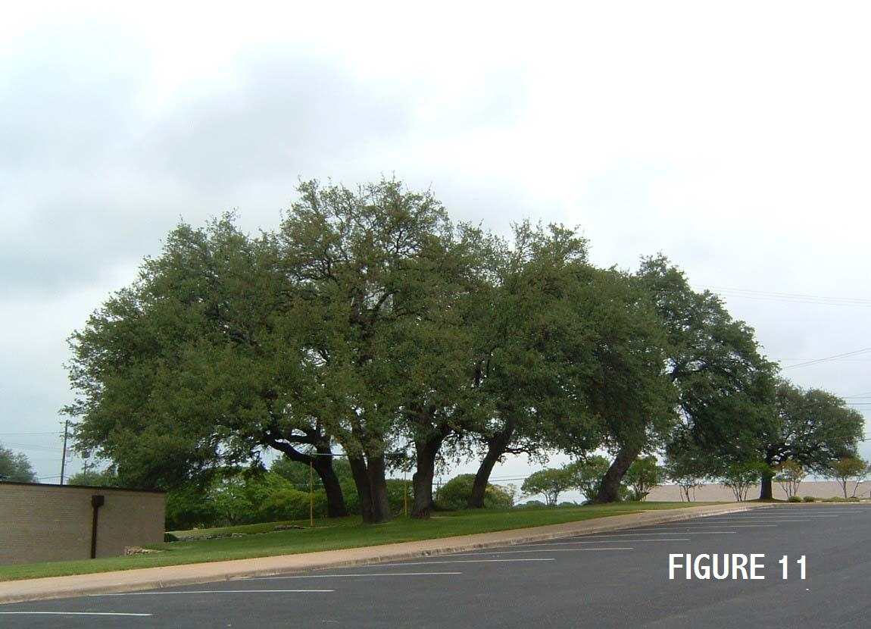
The funds for plan preparation were depleted so renovations could not be made. Frank McCullough, a member of the Bishopric and a professional civil engineer, volunteered to personally revise the plans with the assistance of Gary Robinson. The intent was to minimize the excavation and tree removal and retain the natural aesthetics of the site. After the necessary surveying and plan preparation, the plans were donated to the Architect-Engineer employed by the Building Committee for incorporating into the plans.
Bishop Nelson, also a civil engineer, took the revised plans to Salt Lake City and met with the Church Building Committee. During their interaction with the Bishop, the Building Committee representatives stated “the trees could be replanted”. Bishop Nelson countered by stating “these are not pine trees, they are 200-300 years old and probably will be there when the building falls down”. The Building Committee consented to use the revised plans and every day during the past 36 years members and visitors to the site have enjoyed the trees that still grace the grounds due to the willingness of a few to go the “extra mile” and do what was needed [See Figure 11].

The Parker Lane Building
The enthusiasm and dedication for the new building increased during the construction phase. The building grounds were further beautified by the members while supervised by Brother Don Cooper, a construction contractor, who constructed a rock retaining wall in the area where the trees had been retained. Construction on the building was started on May 31, 1967. Bishop Nelson’s diligent inspection of the construction found the brick walls in the Chapel were unacceptable. So rather than remove and replace the walls, the contractor agreed to place a beautiful wood paneling on the walls that brings a special beauty to the Chapel.
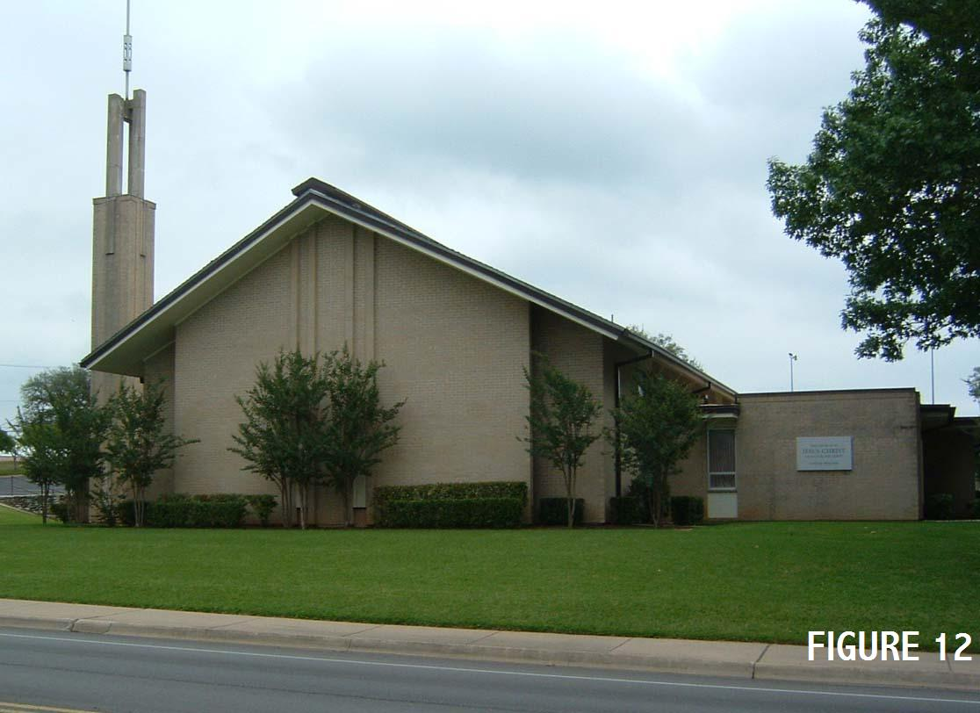
As a result of the prayers, fasting, vision and self imposed sacrifices of the members, they moved into the new building in late 1968. This was just three short years after the members agreed to honor their covenants and make the necessary sacrifices to raise the funds. Six years after sustaining a proposal to obtain new facilities in 1960 they had raised less than ½ of the funds. A comparison of the two different fund raising stages, one of minimal results and one of miracles, is a testimony to the Saints of the Lord’s blessings when they do His will. It is also a testimony of the impact a leader can have when he listens to the Spirit’s whisperings, then “stands tall” to change the mode of operation. On that Sunday night in 1966, the corner was turned in the attitude toward financial sacrifice and the Church began to grow and has continued since that time.
The chapel was dedicated June 13, 1969 by San Antonio Stake President Casey Golightly. During the past 36 years, seven different wards and a stake have utilized and enjoyed the facilities. These include the Austin 1st Ward (later changed back to its original name of the Austin Ward), Austin 2nd, Austin 3rd, University, Barton Creek, Parkwood, and Riverside Wards [See Figure 12].

Two and Then Three Wards
On June 7, 1969, one week before the building dedication the ward was divided to form the Austin 1st Ward with Rex Arnett as Bishop and the Austin 2nd Ward with Garth Thompson as Bishop (formerly Bishop of the Austin Ward). The Austin Ward had approximately 560 members at the end of 1965 and 1,000 members in 1969 when the division occurred.
By early 1972 the Church population had increased to approximately 1,400 members and the Austin 3rd Ward was formed with Woodrow Bledsoe as Bishop [See Figure 13]. 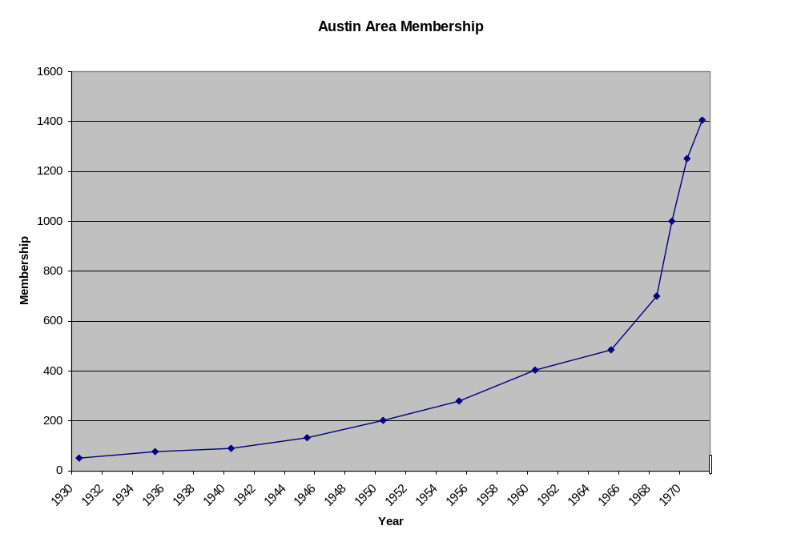It had taken 42 years from the creation of the Austin Branch in 1924 to 1966 for the Church to expand to 560 members. In the three years following 1966, the membership doubled to approximately 1,000 in 1969. By 1972, three years later, the membership had increased 40% by adding another 400 members for a total of approximately 1,400. (Ref. 1)
There was an elapsed time of 29 years from the creation of a branch in 1924 to the formation of a ward in 1958, 16 years to formation of a second ward and 3 years to the formation of a third ward.

OTHER BRANCHES IN CENTRAL TEXAS
As mentioned in the previous sections, the first organization was the Austin Branch which eventually became a ward. Thereafter the continual growth of membership resulted in dividing the Austin Ward and the subsequent subdivisions that resulted in new additional wards. Outside of Austin, the current wards in other counties evolved in a similar manner to the Austin Ward i.e. branch to ward. The San Marcos, Marble Falls, Bastrop, and Riverside Wards evolved from the Austin Ward, while the Taylor and Georgetown Wards evolved as branches from the Austin 2nd Ward (now Walnut Creek Ward).
Up until the 1980’s, the normal evolutionary pattern would be the need for a Sunday School in an area where the driving distances were long and a small number of members lived. Next, a dependent branch was formed that depended on a larger ward for leadership and possibly attendance at the Ward Sacrament meeting. Last would be an independent branch that operated as a stand alone unit but may have reduced programs and a smaller number of members.
The San Marcos and Marble Falls Wards followed this pattern and had several unique experiences in their development that will be elaborated on in subsequent sections. The Riverside Ward, serving the Spanish speaking Church members, was an additional branch inside the City of Austin but experienced a number of “starts and stops’ that gave its development a unique pattern. The Bastrop, Georgetown and Taylor Wards developed in the conventional pattern, thus they will not be covered further.

Riverside Branch / Ward
The Riverside Branch, which was reorganized as a ward in the summer of 2005, has it’s roots of origin go back to the mid 1950s and it’s development was a discrete series of “stops and starts”. In approximately 1955, a dependent branch was organized under the direction and jurisdiction of the Spanish American Mission for the purpose of attracting Mexican American converts. Initially the leadership was furnished by the missionaries and in 1958 Brother Arthur Lung Sr. was called as Branch President with Dr. Paul J. Paris and Dixon Anderson as counselors. The Branch met in a rent house on Willow Street near Metz School in the Tenth Ward. In 1958 the Church Building Committee purchased a lot for $10,000 southwest from the corner of Metz School. Although a building fund was started, the funds raised were minimal and the Church sold the lot in approximately 1975 when the Church was having a cash flow problem and all surplus land was sold.
In 1965 the branch was placed under the San Antonio Stake jurisdiction and the name was changed to the Austin 2nd Branch. Two years later in 1967, the branch was moved back into the Red River Chapel. In 1968 Brother Rex Arnett was called as Branch President with instructions to integrate into the Austin Ward within six months. At the same time the Austin Ward was divided and most of the Branch members were placed in the Austin Ward with a simultaneous translation (delivered in English, and translated into Spanish), and Rex Arnett was called as Bishop. At the time of joining the two units the Branch had 175 members.
Among the original members were the Monreal and Lung Families. Others that followed were Alfred Martinez, Sister Mary Mexia and her children Johnny and Mary Ann (married name Hill), and Eugene Garcia. Other families came and left, but these families have remained during the years. Nadine Coyle (now Sustaita) served on a short term mission when she was called by the Spanish American Mission President.
The small group was dedicated to the Church but experienced struggles that limited the growth among the Mexican American population. In approximately 1957, the Catholic Church in the 2200 block of East 2nd Street was reconstructed to provide a major building for the members to grow into. The Catholic Church had installed a series of pockets on a board in the foyer for distribution of pamphlets to members. Among these pamphlets were some that were negative to the Church. Several missionaries, while visiting the Catholic Church, removed the negative pamphlets and replaced them with Church tracts. While this was done good intentions it basically amounted to thievery. The incident created quite a stir in the community that was reported in local area papers and also in the Austin American Statesman. This event was an embarrassment to the Church and was used as a negative force by the Catholic Priests for years. Compounding the effect of this event was an immoral man who was not a member but was living with Church Members who committed a serious moral act. The scandalous event was published in the papers and the man was reported to be a member of the Church, further compounding the previous problems. In essence, the Austin 2nd Branch did not overcome the negative effect of the publicity until they were incorporated into the Austin Ward. Due to two acts, one by a “well intending” young man without thinking of the long term implication and another of judgment of guilt by association, the growth of the Church among those of Mexican American descent was impeded for a generation.
From 1968 until 1995, several Spanish speaking classes were conducted in the Austin Ward to serve the Mexican American members requiring language assistance. By 1995 the members had overcome the previous problems and the Riverside Branch was formed by Austin Texas Oak Hills Stake President Gary Robinson for Mexican American members residing throughout the city desiring to attend.

San Marcos Branch / Ward
By the summer of 1966, a sufficient number of Austin 1st Ward members lived in the San Marcos Area to form a dependent Sunday school for the area. As mentioned previously, Sunday School meetings were held in the morning and Sacrament meetings were held at night. This meant the members would have to make two trips to Austin for the purpose of attending their meetings. The Sunday School initially met in a picnic shelter on the banks of the San Marcos River. Thomas Walsh, oldest son of Sister Fannie Mae Eckstrom, was called as the Sunday School President. A short time later an abandoned movie house was rented in down town San Marcos and was used to conduct a full set of meetings.
The desire was for the Branch to be independent but there were insufficient active priesthood to preside over the Branch. In 1972, Bishop Rex Arnett of the Austin Ward called six families of the Austin 1st Ward to take an assignment of being San Marcos Branch members for one year in order to serve as a catalyst for development. These members were called to staff positions such as teachers, clerks, etc. and the more permanent San Marcos members were called to the Branch Presidency, Priesthood Leaders, and Relief Society Presidencies. As the Branch grew in numbers, they had a group of experienced members to lead the Branch and eventually a Ward.
Several of the families called from the Austin 1st Ward lived near the Parker Lane Building and it was necessary to drive by the building twice on Sunday in order to attend their meetings in San Marcos. Some of the families were students and the driving required considerable financial sacrifice on their part as well as not having the full auxiliary programs available to their families. In the final analysis, these families were essential in getting the branch started. The members of the wards in San Marcos should be very appreciative of their financial and time sacrifices of these members, for by the time many of them moved into the Ward, a full program of meetings was available. The interesting postlude to these family sacrifices is that not one member of those families live in Central Texas at the present time.

Kingsland Branch / Marble Falls Ward
In June of 1973, after a 122 year absence of the Church in Burnet County i.e. the Mormon Mill Colony of Lyman Wight, the Kingsland Branch was formed as a dependent branch of the Austin 1st Ward. (Ref 12) Brother Kenneth Speer, owner of a furniture and cabinet building business in Kingsland, was called as Branch President with Walter Wells as Counselor and Earl Taylor as Branch Clerk. The Branch rented the American Legion Hall in Kingsland for Sunday meetings.
In 1974 the Branch was struggling with inadequate attendance, calling into question its’ continued existence. Bishop Frank McCullough, of the parent Austin 1st Ward, recalling his experience as counselor to Bishop Arnett in starting the San Marcos Branch, took several steps to assist the Kingsland Branch in its development. Since the driving distance was considerably greater than to San Marcos, he assigned a member of the leadership for the Elders, Seventies, and High Priest Quorums to take their families and attend Church in Kingsland on the first, second, and third Sundays, respectively.. The Bishopric members rotated their attendance on the fourth Sunday. This provided numbers and enthusiasm to the group since they were associating with different members each week. This provided self assurance to the Branch members and a feeling they belonged to a much larger group. To the Austin 1st Ward families participating, it brought the feeling of “going the extra mile” in their service to the Lord on that day.
In addition, the Kingsland Branch Presidency attended the Austin 1st Ward Bishopric Meeting on the fourth Thursday of the month to discuss their issues and participate in a formal meeting. This provided an “on the job training” each month and guidance in their planning for the following month.
During the summer of 1975, it was Bishop McCullough and his family’s time to attend and speak at the meeting. As he prepared to speak, the odor of beer from an American Legion party the night before was strong in the nostrils of the members.. He felt inspired to remind the members that they were a faithful and covenanted people and if they called on the Lord for guidance, they would recognize the Branch needed to locate a better site for their meetings if they planned to grow. By the end of the meeting, the Branch Presidency and the members had individually decided it was time to locate in better quarters. More important, they recognized it would happen when they extended themselves. In a matter of hours, they went from a passive group simply accepting their situation to an active group ready to sacrifice to improve their worship quarters. The Lord answered their prayers and they located a vacated Christian Church Building in less than a week that had not been used for sometime. When the caretakers were located, they agreed to lease the building to the Kingsland Branch for $1.00 per year on the condition that the building was properly maintained.
On October 30, 1976, President Vaughn J. Featherstone, a General Authority, who was serving as the San Antonio Mission President, spoke at the Sacrament meeting, challenging them to prepare for future growth. Over 60 people were in attendance at the meeting and it was the start of a continued growth pattern for the Branch. The building only had the chapel, an office at the front of the building and a classroom at the back of the building but it was a tremendous improvement over their previous quarters. Soon they leased a small building near the chapel to serve as an annex.
The Branch continued to grow so a building fund was started for their own new building. At great sacrifice, the members raised sufficient funds to purchase a lot in Marble Falls since it constituted the center of the membership homes more so than Kingsland. In December of 1982 the first phase of the building was completed and the Branch moved in. At that time, President Daryl Townsend of the Austin Texas Stake permitted the members to vote on a name change from the Kingsland Branch to the Marble Falls Branch. In June of 1989 the second phase of the building construction was completed and President Townsend dedicated the building

STAKE(S) IN AUSTIN
By late 1972 there were three wards located in Austin and the membership was increasing rapidly as previously noted. The membership was highly educated and was professionally involved in management and skilled positions, creating a situation where leadership capabilities were available for Church callings. Furthermore, at that time the members in Austin were contributing to the San Antonio Stake leadership at all levels. The San Antonio Stake High Council expanded to 16-18 members because of the number of units and travel involved. By 1972, the Austin area had 5-6 members serving on the Council.

Change in Plans
Over an 18 month period during 1972-73, five members of the Council; Rex Arnett, Frank McCullough, George Nelson, Amos Wright and Gordon Wright served continuously. These brethren developed a deep sense of unity and brotherhood as they traveled together weekly to Stake High Council Meetings in San Antonio and met informally on Wednesday for lunch to discuss issues involving the Austin area. Naturally, the conversation often turned to the subject of a stake in Austin.
So when Stake President Golightly proposed to the Stake High Council that a new San Antonio East Stake be created that encompassed the Austin wards, the Austin contingent requested consideration for first forming a stake in Austin. President Golightly, after considering the suggestion, recognized the leadership capabilities were more than adequate to staff a stake but the membership numbers were insufficient. In a very unique step, he agreed to contact the stake presidents of the Fort Worth and Houston Stakes to seek permission for the Austin Stake High Council members to contact wards in their stake about forming a new stake in Austin.

Recruiting Wards
On successive weekends Brothers Gordon Wright and Frank McCullough visited the Killeen and Temple Wards, while Brothers George Nelson and Amos Wright visited the Brownwood Branch and Temple Ward. These visits were greeted warmly by each unit, and after discussions with the leadership, all units expressed a sincere desire to join the Austin members in their new adventure. All the units were on the fringes of the Fort Worth Stake and welcomed the shorter travel time and increased opportunity to participate.
The key, and final unit necessary for an organization, was the Bryan Ward. The mileage to Austin or Houston was equidistant but they had approximately 20 years of tradition with the Houston Stake as well as economic ties. In addition, they had recently experience a miraculous building fund raising experience similar to the one in Austin, Unfortunately, when the bids for their new building were opened, their share was $23,000 over the estimate. After another push for funds, they obtained an additional $13,000 and the Houston Stake contributed $10,000. (Ref. 10) This was the scenario faced by “fasting” Gordon Wright and Frank McCullough during their visit to Bryan. After the Austin proposal was made, the Bryan leadership made the decision to join Austin in spite of their ties to the Houston Area. Needless to say, the Austin Stake High Council contingent was thankful and thrilled when the emissaries returned with the news. Now there would be a stake in Austin subject to the approval of the stake presidents and the First Presidency.
Few in the Austin area are now aware of the debt of gratitude owed President Golightly for his support in organizing a stake in Austin. This support meant a stake was formed in Austin much earlier than originally planned and the cost was approximately a four year delay in the start of their second stake i.e. the San Antonio East Stake.

Organizing the Austin Texas Stake
As the possibility of a stake increased, the Stake High Council group from Austin thoroughly discussed operational methods for the new stake. They mutually agreed if one of the group was selected as Stake President, they would consider the use of the new operational outline. Following are a few of the ideas that were eventually incorporated in the stake operations and, for the most part, have been carried to the present time in the Austin Stakes:

All stake auxiliary meetings would be scheduled on one Saturday in the month – Super Saturday.

Stake High Council meetings twice a month rather than weekly and the meeting time limited to approximately one hour.

Stake meetings would occasionally be scheduled in the outlying cities.

During 1973 the Austin Stake was organized and Amos Wright was called as Stake President with Gordon Wright and Woodrow Bledsoe as first and second counselors. The Austin Stake combined units from three stakes – San Antonio, Houston, and Fort Worth- in a unique example of cooperation and coordination between numerous units and individuals. In less than three months from start to completion, a plan was created, implemented, transmitted through the approval process and then brought to fruition by individuals not acquainted with one another or without the modern communication methods of emails and faxes that exist today. The wards involved were the Austin 1st, Austin 2nd, Austin 3rd, Bryan, Killeen, Waco, and Temple plus the Brownwood and San Marcos Branches [See Figure 14].
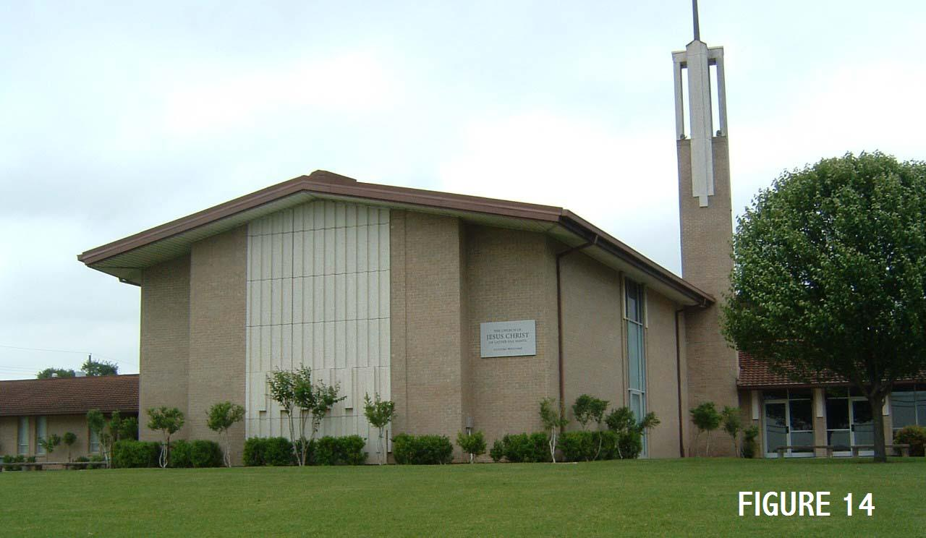
The wards from the Houston and Fort Worth Stakes were welcomed and quickly merged into the stake organization by calling representatives of most wards to the Austin Stake High Council and numerous individuals to stake auxiliaries. Stake meetings and Stake High Council meetings were scheduled in most of the new cities to demonstrate the stake leader’s willingness to work at the “grass roots” level and share in travel. This positive “can do attitude” combined with the growth in numbers and meeting management had immediate results. Within six years, the wards from the Fort Worth area were included into the formation of the Killeen Texas Stake and the Bryan Ward joined the Houston Area to form the Houston Texas North Stake in the late 1970’s.
These divisions resulted in the Austin Texas Stake having the boundaries of the Central Texas Counties previously described [See Figure 1].
By December of 1991 the membership had increased to the point that the Austin Texas Stake was divided and the Austin Texas Oak Hills Stake organized. Gary Robinson was called as the Stake President after being released as President of the Austin Texas Stake. Wayne Sturdevandt and Frank McCullough were called as 1st and 2nd counselors, respectively. The history of the Oak Hills Stake is reviewed in Appendix B prepared by Bill Cannaday. Basically, the Austin Texas Stake was from the University area north and included the Marble Falls Branch (now Ward), and the Oak Hills Stake was to the south and southeast. President Nielsen was sustained as President of the Austin Stake.
In 1999, the wards to the north and northeast of Austin were separated from the Austin Stake to form the Round Rock Texas Stake. The Bastrop and Austin University Wards were moved from the Oak Hills Stake to the Austin Texas Stake.

SIGNIFICANT EVENTS
From the time of the creation of the Austin Ward to the creation of the Oak Hills Stake, a number of significant events have occurred that have significantly affected the Church in Central Texas and in some cases, non-members in the area. It is not possible to be all inclusive of these events but several of the more prominent are described. The examples all illustrate the fact that it is not hard to make the right decisions if they are based on values that are fundamental to the gospel, but their implementation may require sacrifice.

Starting the Seminary Program
At the start of the 1963-64 academic school year, the Austin Ward Bishopric desired to start the seminary program. After years of struggling, there were finally sufficient high school students to begin Seminary classes. The potential existed, but they were faced with a critical problem of transportation. Over 50% of the parents would not or could not drive their teenagers to the early morning class. Since they were spread throughout the city, it was not possible for those few parents willing to drive to pick up all the youth needing rides.
After fasting and prayer, the Bishopric decided to use as a resource a large active group of young married couples with young children. They individually called the young couples to pick up the youth in the area they were assigned for one week every 3rd or 4th week and deliver them to the Red River Chapel. Another group was called to take the youth from the chapel to high schools all over the city after seminary.
The young married couples who had been called by the Bishopric to make the program work generally were struggling financially and dealing with the daily logistics of getting their own children to school. This meant waking before 5:00 am, leaving by 5:30 am to drive across town, pick up the youth and deliver them to the church. Fulfilling the assignment on cold winter mornings with youth reluctant to go to the church every day became a test of endurance and introducing into one’s mind the many logical justifications for being released from the assignment. Yet most continued month after month for three years until the program was self-sustaining and the parents took care of the transportation. Those making the sacrifices initiated a great Church program that apparently had no immediate direct impact on their lives.
Looking back and accounting for those youth that remain in the area, many are serving in key positions for the wards and stakes that were and are instrumental in the growth of the church. Some are inactive and have not attended church since their high school days. More important the young married couples providing the catalyst for the program had experienced a metamorphic spiritual change as a result of their sacrifices. It is not normal for the natural man to sacrifice for continued periods of time and this only comes with a spiritual change from continual prayers to sustain them. These couples became the Auxiliary Presidents, Bishops, Stake Presidents, etc over the next 40 years of church activities in the Central Texas area. There was also a serendipity blessing involved, with a vibrant active seminary operating when their children were old enough to attend.

Local Contributions to the Missionary Program
In a short time after formation of the Austin Texas Stake, the benefits of the total church program available to the youth and the growth of the Church were very evident in the missionary program. The calling of young men or women to the missionary program in the Central Texas area from the formation of the branch in 1924 to the present year of 2005 can be divided into three distinct time periods of approximately equal length.
For the first 26 years of existence from 1924, there was not a missionary call extended to a young person from the Austin Branch. In January of 1950, John Edgar Jackson was called to the North Central States Mission where he served a faithful mission. He was the son of Carl and Annabel Jackson of Austin and also the grandson of Fannie Eckstrom. After his mission, he married and lived in Austin for a period of time with a large family
During the next 25 years only one man, a recent convert, was called from the Austin area. Although he left from Austin, he never returned to live in the area. In the transition period from branch to ward and stake, numerous youth became adults with out missionary service since there was no tradition or preparation with which to do so.
The third period started in the mid 1970s, when young men and women reached age eligibility, were called on missions. They accepted and served honorable missions of service to their fellow men and to God by preaching the gospel in all areas of the globe. Then returning to their homes, studying in universities, serving in ward and stake positions, and most of all, raising fine families, they became excellent examples for other young people to follow. There was first a trickle of young men going and soon there were many – establishing a tradition.
During the past few years, the stakes were blessed with second generation missionaries from Austin that followed in the path of one or more parent who had left from Austin to serve on their missions. These second generation missionaries are the result of many sacrifices personally by parents and others that provides an example of continuity and stability to the area.
A postlude in the local contribution to the missionary program was the calling of retired couples to be missionaries. Dr. Paul J. and Sister Ruth Paris, in the late 1960’s, served a very successful proselyting mission. Then for 30(+) years during the development period of wards and stakes, subsequent calls were, for all practical purposes, non existent for couples. Upon the release of Gary Robinson as the Austin Texas Oak Hills Stake President, he and his wife Connie Robinson, desiring to serve a mission, to set a precedent and serve as example to other couples served a mission to Nigeria. Since that time, numerous other couples have served proselyting and labor missions.

The Blood Sacrifices (Ref. 13)
The descriptions of the past revealed that the maximum gains were generally made after many sacrifices but the involuntary blood sacrifice of two young elders had and continues to have a major impact on the members and non-members in the Central Texas area. The story begins in October 1974 with two young Elders serving in the Austin Ward and providing fellowship for a recent convert who was active but soon to be found mentally unstable. Elder Gary Darley from Simi Valley, California and Elder Mark Fischer of Milwaukee, Wisconsin were enthusiastic young men very interested in the people they were serving. They were, in this case, having regular Monday meals with Robert Kleason as a means of fellowshipping. Kleason, as time would prove, was a game poacher, a thief, a record of preying on young men and women and a murderer. Yet he was able to charm young men with his large gun collection, his hunting experiences and fictional stories of his experiences as a CIA Agent.
In a parallel set of events Bishop Frank McCullough, recently called as Bishop of the Austin 1st Ward, received an unusual letter from Kleason requesting a visit to his home at night and not to tell anyone he was coming. The next day Bishop McCullough spent the afternoon studying the letter and a large number of letters from Kleason to Bishop Bruce Smith, the previous Bishop. At the end of a two hour session of pondering over the various letters, recent events, and after a concluding final prayer, Bishop McCullough received an answer to the issue that was troubling him about the letters. The answer he received was not found in the information contained in the letters but rather, in a spiritual answer to his prayers indicating the root of the problem was sexual orientation and this was later confirmed in the police cross examinations.
Bishop McCullough immediately counseled the missionaries not to visit Kleason and after finding out two days later that they were still visiting him, he immediately counseled again. The reply was that they planned to honor their non-visit commitment after one more Family Home Evening visit. Prior to going to Kleason’s home, they visited a family investigating the Church and this was the last time anyone ever saw them alive. Kleason, after a short time, was arrested, tried, convicted and sentenced to the death penalty for the murder of the missionaries. He was later released on the basis of an appeal to the Texas Court of Criminal Appeals that the evidence used against him was obtained illegally. He was convicted and sentenced to 16 years in prison by the Federal Government for illegal possession of firearms.
The event had a significant impact on the members and the community as highlighted in the following summaries:

The testimony that the Lord directly inspires his servants and not following the counsel may have a major impact on one’s life.

The members were asked to forgive the perpetrator and not think of revenge. The congregations followed the counsel and went forward.

The organization of the Church was demonstrated in two major mobilizations of members for search parties. On Tuesday afternoon, two days after locating their missing car, the police officials requested 75 men for a search party on Wednesday afternoon to look for evidence on the 4-5 acres surrounding the Kleason trailer. On Thursday afternoon, they requested 1000 people to search the rural roads west of Austin on Saturday morning. The numbers were exceeded in both cases and all the logistics were planned and led by the Priesthood. Members from Austin, San Antonio, Houston and many small towns in-between came to assist. The city, county, state and federal officials as well as the television reporters were moved by the effectiveness of the Priesthood in action.
Several interesting other developments are worthy of note:

The television and newspaper gave extensive coverage to all events and the TV program covering the massive search was a moving experience to member and non-members.

Two of the search party members found over $2,000,000 in counterfeit money and the $20 plates used to print the money hidden along the right-of-way road. The counterfeit ring was broken one week later by the Secret Service.

However, the most significant event occurred a few weeks after the search parties during a Stake Quarterly Conference when a counselor to the Church Presiding Bishop, Vaughn J. Featherstone, made the following pronouncement. “The Lord is very angry for what has happened, and he will bind Satan for a period of time and the missionary work will go forward as never before.” A time period was not specified, but the missionary work has proceeded at a more sustained rate ever since.

The Extra Mile – Community Service
As a part of the Bi-Centennial Celebration for the 200th year of the United States, The First Presidency of the Church requested each ward to conduct a special community service project. Most wards pursued the typical cleanup projects but a unique opportunity was provided the Austin 1st Ward that was to have a lasting impact on the community.
At that time Sister Norma McCullough, wife of Bishop McCullough, was a member of a service group “Now or Never” whose purpose was to secure a large block of land west of Austin. Their objective was to provide a wilderness preserve for students, families, hikers and other nature lovers to observe the pristine nature of the Hill Country. The land of interest was just north of Bee Cave Road and inside of the then proposed Loop 360. Although the entire area from Bee Caves Road to Lake Austin was inaccessible brush country at the time, it was considered as a prime area for high dollar homes and office buildings by developers – as it proved to be in time. 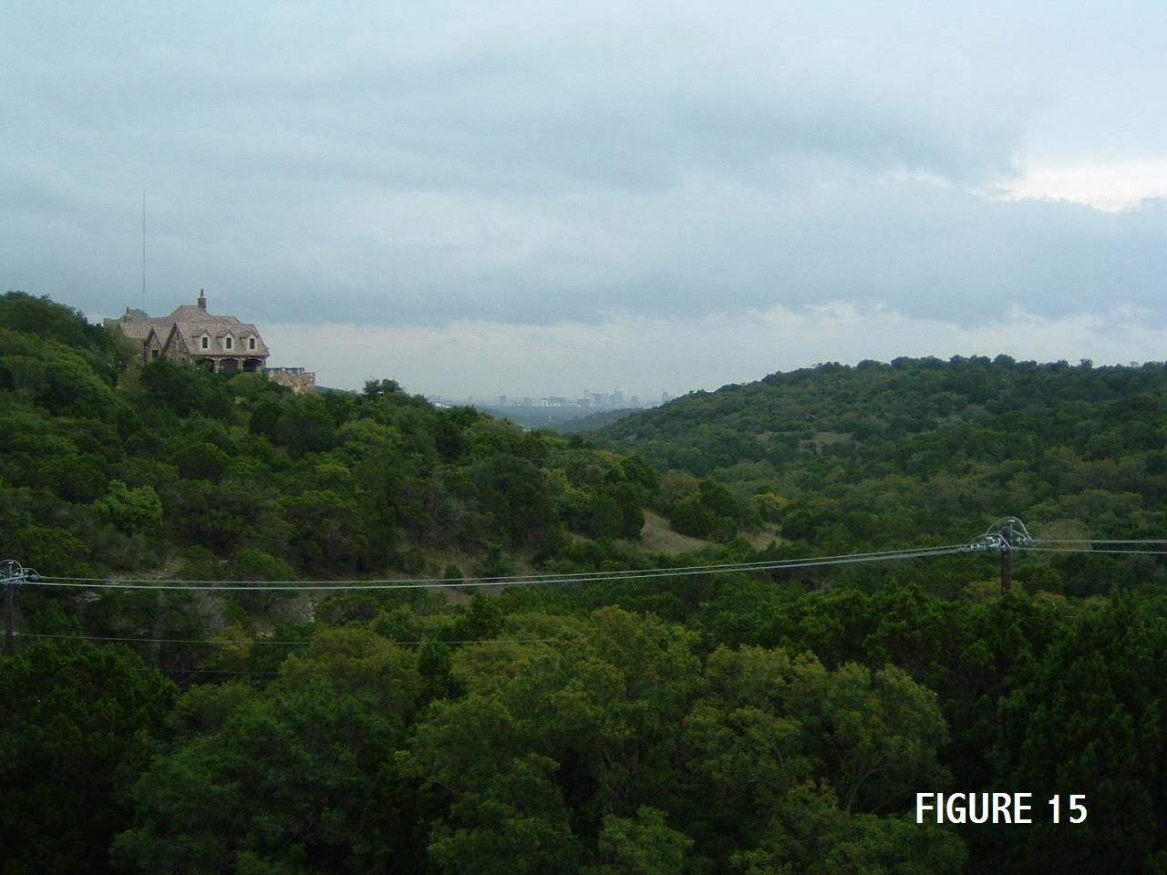[Figure 15 is a photograph of the Wild Basin Wilderness Area from Loop 360 taken in 2005 showing the city and adjacent homes developed in the area]. This created a conflict of interest between the objectives of the two groups since a nature preserve with all the environmental restrictions was the last thing the developers wanted.
It was at this time that Sister McCullough asked her husband and Bishop if it was possible for the Ward to participate in the fund raising activity for an outside group as a Bi - Centennial Project. The Bishop then met with Mrs. Janet Poague, the organization president, to evaluate the potential. There he found they needed about $10,000 more in funds in order to receive a Federal Grant that would permit them to purchase the land. Unfortunately, they were running out of time with less than a month left until the deadline for the grant application. The group could not secure any publicity in terms of newspaper advertising or articles in the papers expounding on the benefits of a Preserve. The location was too far from the City of Austin at the time for any City interest. These constraints raised some question about this being a Ward Project since the fundraising would come to naught if the deadlines were not met.
Even with these constraints, Bishop McCullough took the proposal to the Bishopric and then the Ward Council; they enthusiastically approved the project and recommended a giant yard sale. A planning committee was called next consisting of Brother John Curd as the chairman and several members serving as committee members. The proposed plan was presented to the Ward membership and they unanimously approved it. A location was secured for a Saturday in the parking lot of the Academy Hardware Store that was located on Ben White Boulevard at that time. The Blue Sunday Law was in effect so stores had to close on the Sabbath and since the owners were of the Jewish Faith, they typically closed on Saturday and opened on Sunday. Several funeral homes lent large tents for shade and cover.
Within a short period of time the leaders and the membership took on a “messianic” enthusiasm for the project. Members visited all types of businesses and after explaining the purpose, the businesses generously donated their products to the “Sale”. Brother Curd approached the local “TV Talk Shows” for live time on the TV. While on the shows he explained the purpose of the Preserve and then invited all to attend the “Yard Sale”. Soon the local TV Weatherman joined the publicity and donated an autograph copy of the daily weather maps to the sale and gave it an enthusiastic endorsement each day. The small group of ladies had been working for several years struggling to get any type of publicity with minimal fruition. Yet in a few short weeks, the Austin 1st Ward had accomplished ten fold their effort in getting the message of the “Preserve’s” purpose out to the general public due to the dedicated, prayerful efforts of the Ward members.
Finally, the Saturday arrived with beautiful weather and people from all over the city attending to purchase the merchandise and, in a small way, contribute to the project. By the end of the day all the merchandise was sold but only $4000 was raised. Although this was a large sum in 1976, it was still short of the $10,000 needed. After officially closing the event, there was to be a formal presentation of the funds to the Now or Never Group. The Church Leaders were disappointed that it fell short of the goal but were pleased with the dedicated effort of the members and the positive publicity for all. The Group had their message placed before the public and the Church was recognized for its efforts on behalf of the community.
During the meeting an event occured that all attending considered a miracle when a man walked in and wrote out a check for the balance of the needed funds on the behalf of an anonymous donor. The benefit of the project had been recognized as well as the Christ-like efforts the members had given on behalf of the community. Many years have passed since then so suffice it to say the man was representing the family of one of the large food chains in Texas.
A grant was requested and approved for the Federal Funds with the Austin 1st Ward and the “Now or Never” Group as the sponsors. Almost 30 years have passed since that event but the public driving along the west side of Loop 360 can enjoy viewing 225 acres of pristine Hill Country among the mansions and office buildings that surround it. Or if they choose, they can explore the area and enjoy its beauties by hiking on the trails through the area..
Since then, the Now or Never Group has been enlarged and the preserve goes by the more descriptive title of Wild Basin Wilderness Preserve. Every year there is a gala fund raising dinner with all of the city’s elite in attendance. Until Janet Poague’s death, the Church and the Church leaders were invited to attend the events and whenever she met Bishop McCullough at the local businesses she always acknowledged it would not have occurred without the help of the Saints.
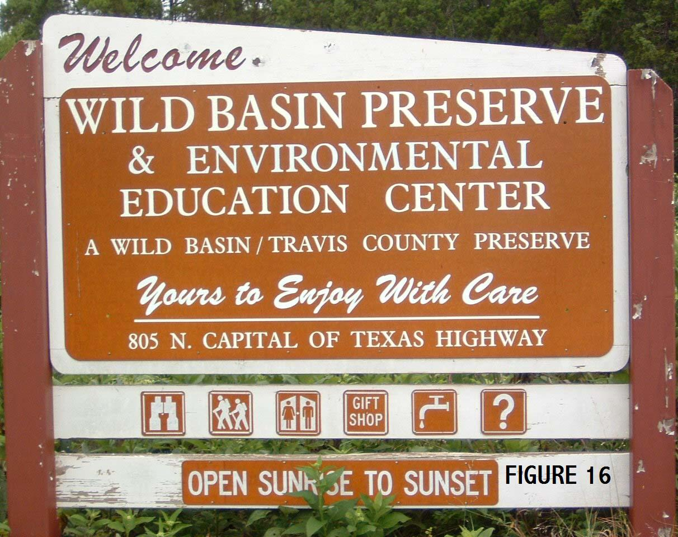
Today, visitors to the Wild Basin Wilderness Preserve have no connection with the effort of the Saints in establishing the Preserve. Yet all that participated in the effort can look at the signs and feel an inner warmth of the legacy they left the City of Austin [See Figure 16].

Recreation Areas
As mentioned previously, approximately 6.3 acres was purchased in 1962 at the Parker Lane site with 3.7 acres being used for the building and parking. The members and local leadership always had a vision of using the remaining 3 acres for recreation. The area was fenced off at the direction of the Church Building Department since they had plans for eventually placing it for sale as it increased in value since it was not landlocked at that time. With available land and a numbers of dreamers willing to pursue tasks to the end, the Austin area congregations soon had a picnic area and a softball field available to the members. Their development was a testimony of dedication of service by many.

Walter Jones Park - By 1971, the city was growing and it was more difficult to rent or schedule a recreation area for an outdoor activity by the wards. Therefore, the Austin 1st Ward Bishopric made the decision to construct a picnic area on the northeast corner of the lot. This area was on top of the hill with a view into downtown Austin, and it was covered with a large grove of live oaks. At that point in time they did not seek permission from the Church Building Committee since the investment for constructing the tables was small other than in donated time.
Brother Walter Jones was called to lead the development since he worked in the construction industry for years in foreman type positions. Each Sunday Brother Jones would invite anyone desiring to participate in a work party on Tuesday through Friday to come at 6:00pm. Some days, he would only have 2 or 3 takers and on others 15 plus people but he was enthusiastic in the work every night regardless of the numbers.. Shortly after taking on the assignment, he was diagnosed with Hodgkin’s disease. After a short time it was obvious his health was failing. Brother McCullough and the Bishopric Counselor assigned responsibility for the project asked Sister Jones if her husband should be released but her reply was that the project was keeping him alive, so the work, continued.
In early spring the park was completed with three long concrete tables capable of seating over 200 people. In addition, a large BBQ pit was placed on a large concrete slab with a concrete serving table and a large fireplace was built with small amphitheater seating to use for various Church gatherings.
After the completion of the project the Austin 1st Ward hosted a large BBQ dinner with over 450 people in attendance. In recognition of his service, the park was dedicated and signed as the Walter Jones Recreation Area. Everyone in attendance was pleased with the act as well as a surprised Walter Jones. Within a few short months, Brother Jones passed away with the disease but he left a legacy that many have enjoyed since that night.

Frank McCullough Field – The desire for utilizing the remaining parcel of land for a softball field was a dream of many. During the period when only one ward existed in Austin, the Ward softball team won two city wide church championships (all denominations), and numerous San Antonio Stake Championships. This created a high level of interest from the wards as they evolved for softball and other sport activities.
During the mid 1970s there was a major push in the San Antonio Texas Stake and later the Austin Texas Stake to collect funds for constructing a stake center. The memberships financial resources were stretched to the limit so the funding for construction of a ball park was unthinkable but financial help was on the way from another source. In the summer of 1977 the stakes in the church were assigned responsibility for paying all building operational expenses with 100% of the funding provided by Salt Lake. This removed a major financial burden from the building’s Agent Bishop. Prior to this time the agent bishop would pay all bills at the end of the month and collect each ward’s proportional share of the 30% owed by the local units and wait three or more months for the other 70% share furnished by the Church Offices. Bishop Frank McCullough, who was being released at the time, recognized there would be $3500 - $4500 available to the Austin 1st Ward at the time of transitioning finances. Bishop McCullough suggested to his successor, Bishop Don Cooper, that he take up with the Ward the use of the funds for a ball park.
After the Ward approved the use of the funds, Bishop Cooper hired an earth moving contractor to grade the land for a softball field and recreation area. The grandstands, backstop and dugouts were constructed through ward and stake projects over the years. In the early 1990's lights were added through the foresight and recognition of available funds from Salt Lake by the Oak Hills Texas Stake President Gary Robinson. Through his guidance and personal effort, the field and the recreation area have been turned into one of the better sites in the city.
In connection with the July the 24th Celebration by the Oak Hills Stake, President Gary Robinson made the decision after consulting numerous people to name the field in honor of his First Counselor. During a special ceremony in connection with the celebration on July 23, 1994, President Robinson named the softball park Frank McCullough Field as a tribute in honor of his long term services to the Church in the Austin area [See Figure 17].
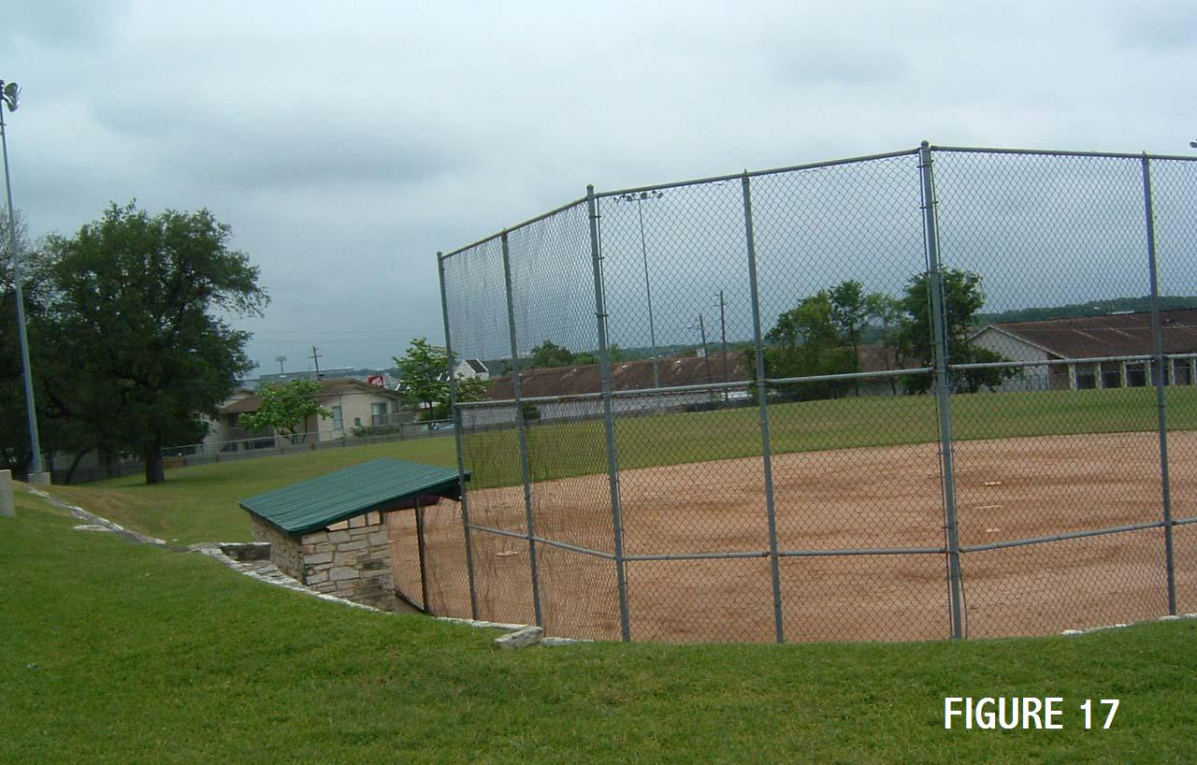
Postlude – First, the land used for recreation areas took a special effort by several leaders to preserve it from sale by Building Department over the years. The first test came in 1975 when the Church was experiencing a “cash flow” crisis. To help solve the problem they starting selling off all surplus land and the park area was on the list. Bishop McCullough requested the Church Building Department Representative to meet him at the site (the picnic area was in place). Fortunately it was a beautiful spring day in Texas with all the wild flowers in bloom, especially the bluebonnets, in what is now the softball field. After explaining the sacrifices made by the members, the plans for the future, and the enjoyment experienced by all at the site, Bishop McCullough made a direct plea to let the local wards keep the site. The representative agreed and made the decision to remove it from the list of available sites.
The next major test came in the early 1980s when the Church was experiencing another “cash flow” crisis and proposed to sell the land. The fund raising for the Rutherford Stake Center was past so Bishop Robinson, the Agent Bishop at the time, permanently eliminated the crisis from ever occurring again by paying approximately $5000 to the Church for the local and Salt Lake share of the cost.
When the leaders have the vision to think long term and the dedication to make changes exists among leaders and a willing membership, then an earthly experience of eternal progression will occur. The results are a legacy of enjoyment that will be experienced by the members for generations to come.

LOCAL NON MEMBERS & THE CHURCH

Two individuals, prominent in Texas History buried in the Texas State Cemetery played key roles during a critical period of Church History known as the Utah War when Johnston’s Army marched into Utah. One of the individuals was Ben McCulloch a resident of Gonzales County in Central Texas and the other was Albert Sydney Johnston, a resident of the eastern part of the state.
The Utah War started from a combination of poor communication between the Saints in Utah and the Federal Government – especially President Buchanan. It started with a series of ludicrous charges contained in a letter to President Buchanan by a scandalous Federal Judge in the Utah Territory and was further inflamed by the unfortunate events associated with the Mountain Meadow Massacre. (Ref. 4) As a result of these events President Buchanan sent an army of 2500 officers and men to Utah under the eventual command of General Albert Sydney Johnston. Before further unfortunate events occurred, the issues were resolved by reasonable men on both sides.
General Johnston was a career officer in the U. S. Army and a graduate of West Point and a product of the “Planter Caste” covering East Texas and the South. Some historians have speculated this move into Utah was a diversionary tactic away from the slavery issue and with other objectives. (Ref.14) After the Utah incident, General Johnston continued to serve in the U.S, Army until he resigned at the start of the War Between the States to join the Confederate Army. He was the Confederate Army Commander at the Battle of Shiloh in Tennessee, where he was killed early in the battle. His body was returned to Austin and buried in the Texas State Cemetery after a large memorial service
Ben McCulloch had a distinguished record of service to Texas and the nation starting with the Battle of San Jacinto, followed by serving as a Texas Ranger Captain, hero in the War with Mexico, a federal marshal, and lastly as a Confederate Army General. He was a confidant of Sam Houston over his entire career. In 1857 Sam Houston was serving as a U.S. Senator where he strongly opposed the creation and use of Johnston’s Army. Since he was not a member of the Planter Group, he possibly recognized the diversionary tactic of using the army. On the Senate Floor he made a speech recommending Ben McCulloch be sent to Utah as a Peace Commissioner to resolve the issues. (Ref 15) As a result, President Buchanan appointed Ben McCulloch and another individual as Peace Commissioners. They journeyed to Utah to mediate and help to resolve the issues between the Federal Government and the First Presidency of the Church. Ben McCulloch felt the use of the U.S. Army in Utah was necessary, but once the army was sent, burning the wagons was an act of treason. Therefore, true to his character, he was resolute in this being recognized and for which an apology was issued.
After his Utah service, Ben McCulloch returned to Texas and later was appointed as a General in the Confederate Army at the start of the War Between the States. He was killed during the Battle of Pea Ridge in Arkansas and his body was returned to be buried in the Texas State Cemetery after a large memorial service. (Ref. 14)

.

SPIRITUAL EVOLUTION

The history of the events, organization, people, etc. described in the previous section provided the members with opportunities to expand their spirituality to various levels depending on the cumulative product of their obedience and dedication. The first step in this process is the same as the Prophet Joshua gave Israel prior to his death after a long and successful role as the successor to Moses:
“…choose you this day whom ye will serve; …but as for me and my house, we shall serve the Lord.” (Joshua 24:15)
Every person involved in the history has at some level chosen to serve the Lord but the level of their obedience and dedication has varied. Some people are like soft stones that experience a metamorphic change under heat and pressure that makes them strong and durable like marble and granite. They increase in spirituality as their level of obedience, dedication and sacrifice increase. In the following sections, the member’s spiritual growth is discussed as they responded to this “heat and pressure” experienced during the development of the Church in Central Texas.

LOST OPPORTUNITY
The Texas Mission of Lyman Wight reviewed from the perspective of the potential it presented and considering the events in the subsequent 160 years since it was first proposed must be judged as a “lost opportunity”. The Church Leaders had envisioned Texas at various times in the 1840’s to be: a potential site to which to relocate, a place of immigration for the converted members from the South, an opportunity to convert the Indians, etc. The latter two purposes were stated at various times by the Prophet Joseph Smith and restated by Lyman Wight. The two key questions are then: what was the relative potential of the Hill Country, and second why was the opportunity lost?

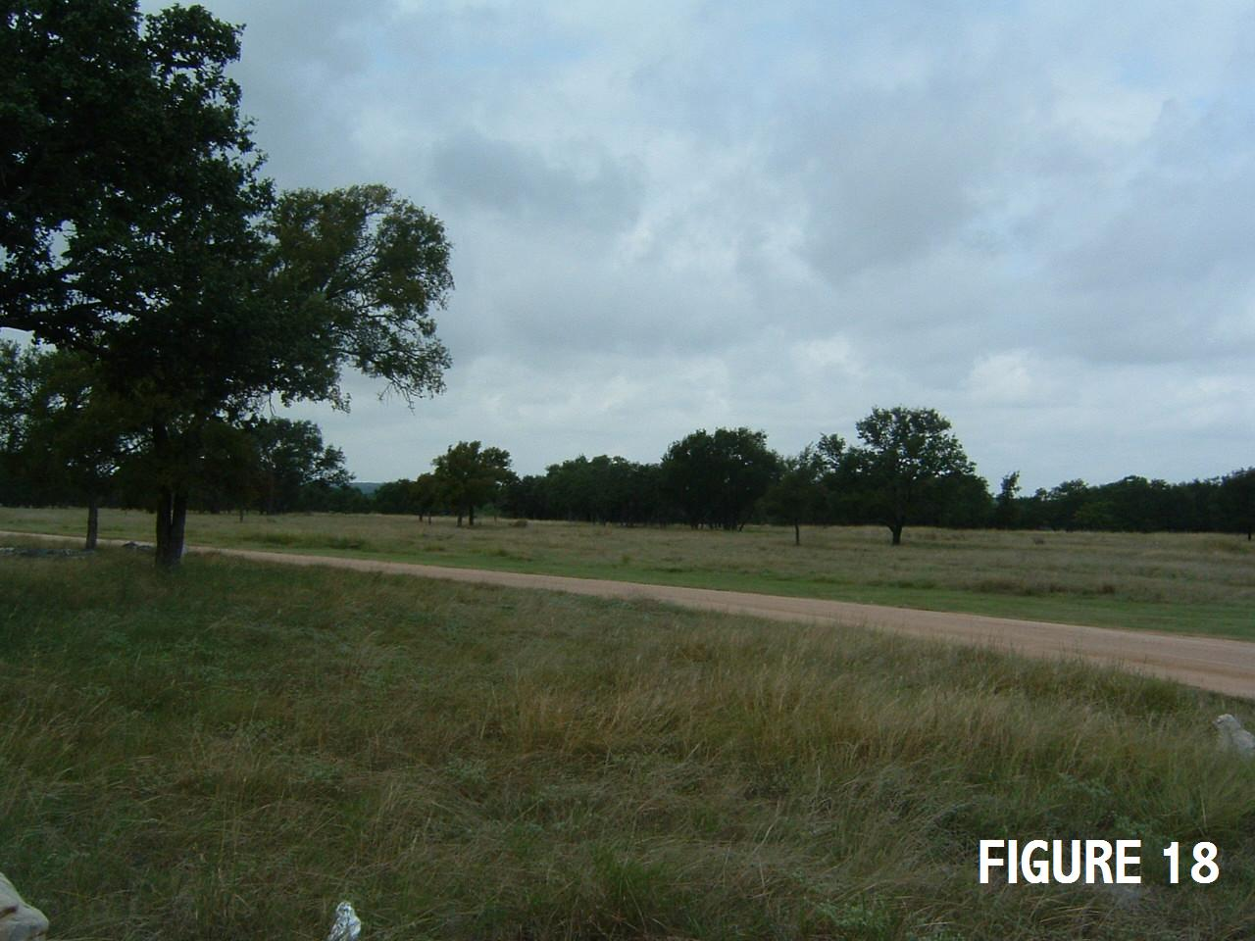
Potential of the Hill Country
The Texas Hill Country west of Austin would have been an ideal “gathering place” for the converts from the Southern States. First, the population was sparse from the 1830’s to the 1930’s with abundant available land. Public lands in Texas are state owned compared to the other states where it federally owned and over the years it has been transferred to various groups at minimum or no cost. The Hill Country of the 1840’s to the 1880’s was entirely different than now, covered with oaks (the junipers came later) and a rich prairie grass and, except for years of extreme drought, had adequate water available [See Figure 18]. The land was never considered acceptable for cotton farming as was East Texas and the South, thus was not desired by the plantation society. Yet the potential of the area was demonstrated by groups such as the German Colonies along the Guadalupe River that lived a prosperous and comfortable life and continue to so at the present time.
In general, the acceptance level would have been good since the Central Texas area was settled in different regions by the German, Swedish, and Czech groups with each establishing its’ own communities, style of life, language, and traditions. This, along with the general movement from the South for reasons of economics, available land and escape from the past resulted in the commonly recognized sign GTT “Gone to Texas” that brought a level of acceptability for those who were different.
The potential is partially demonstrated by the Church Colonies, such as the Gilmer, Kelsey, and Williamson Colonies, established in East Texas after The War Between the States. Here, recent converts escaping from persecution in the South gathered to start a new life and establish a home for the Saints. These were isolated success stories that the Prophet Joseph Smith had desired Lyman Wight to accomplish on a larger scale in Texas.

Lessons from the Failed Colony
Lyman Wight was an Apostle when he departed for the Texas Adventure and he was sustained as an Apostle in the October 1844 and the April 1845 General Conferences. He was one of Joseph Smith’s companions for the period of the Liberty Jail confinement. He was present in 1839 at the Liberty Jail for the events leading to prayers and prophecies recorded in Sections 121, 122, and 123 of the Doctrine and Covenants. The counsel given in these Sections of the D&C has been a source of inspiration for members since that time and their spiritual nature has led writers to refer to the Liberty Jail as a Spiritual Prison. In 1841, approximately two years after the Liberty Jail confinement, Lyman Wight and others were instructed by the Lord to build the Nauvoo House (D&C 124:22-24, 60). Even though he had all the prerequisites for success, he was disfellowshipped from the Church in approximately 1849. It is not completely clear why this occurred, but it appeared he was non communicative with the main body of the Church and did not fully accept Brigham Young as the successor to Joseph Smith.
Prior to 1846, both Brigham Young and Lyman Wight were strong willed Apostles and devoted followers to the Prophet Joseph Smith and his Mission. With the martyrdom of the Prophet Joseph Smith, their relative position changed since Brigham Young eventually became the President and Prophet of the Church while Lyman Wight was still a member of the Apostles with a new leader Numerous reasons can be given for the subsequent events, but in the “bottom line” is that this change was never recognized and the potential of the Texas Mission never being fulfilled.

A MIGHTY CHANGE IN HEART
During the first forty years after the Church was organized and grew from a Branch to a Ward, their were two periods when the Church experienced substantial growth periods beyond the normal population increase. In order capture the significance of these periods on the development of the Church in Central Texas, one must capture the perspective of the increase and then explore the reasons for it.

Characterizing the Growth
For a fifteen year period from 1951-1966, the various Elders Quorum Presidents of the Austin Ward planned home teaching for 300-400 ward members. As mentioned previously, this encompassed for the most part the 10 county area surrounding Austin. In 2005, 40 years later, there are 3 stakes, 30 wards and branches, over 12,000 members, and 14 buildings covering that same area.
For the first 15 years of the past 52 (+) years after the Austin Ward was established, the Church’s growth rate was slightly less than the growth rate of the City of Austin. During this period, the members prayed that the Lord might provide an increase in the congregation. In contrast for the past 35 years the population of the Central Texas area has increased approximately four times, whereas, the Church membership in the same area has increased 35-40 times. In other words, the membership has increased almost 10 times faster than the City’s population. By any statistical or common sense measure, this is a significant statistical difference or in everyday English – this is a staggering increase.
This leads to the logical question –“what caused this difference?”

Why the Difference?
During the period of low growth, many members felt the Church membership would never increase until we had adequate facilities to worship in and to which to bring our neighbors. The Red River Chapel was a wonderful home for a branch but approached an inadequate status for a ward and any future growth. There existed another group that felt the facilities were satisfactory and were not overly enthusiastic for the “Building Fund” activities the ward had undertaken as previously described. No matter the sentiments of the various people, a common thesis for all was that the funds would be obtained by various fund raising projects that utilized the labor of the Saints. Essentially this type of approach produced excellent results when the manual labor of the Saints provided the local contribution for the construction of the Red River Chapel. During that period of time, the local contributions of the congregation provided 30-40% of the cost through donated labor and Salt Lake furnished the balance of the cost. To raise the funds for the new building in a similar manner was taking the easy way out. In essence, the members were paying themselves for potluck dinners, donating labor to group fund raising projects such cleaning houses for builders, etc.
As the Ward struggled with fund raising due to the amount being accumulated not keeping up with the inflation of the building cost, it appeared to be a never ending endeavor. At the time when the spirits for fund raising was at low ebb, a new Bishop, George Nelson, was called for the Ward. Within a short period of time he stated from the pulpit that the building would come when the Saints in Austin were willing to live up to the covenants they had made. In other words, it would come when the members made the necessary sacrifices in terms of money as well as time. The message delivered from the pulpit was basically a repeat of the question Alma asked the Church members in the City of Zarahemla in the 5th Chapter of Alma, when he asked “…have you experienced a mighty change in your hearts?” The membership sustained the Bishop’s proposal on that fall night in 1965 when he called for a show of hands. More importantly, a “mighty change in heart” occurred among the members as many great miracles happened to individuals when they made great personal sacrifices to donate their assessments. The individual miracles culminated in a Ward miracle of the funds being raised in less than five months after years of “spinning our wheels”. Less than 18 months later, the congregation was moving into the new building on Parker Lane. Then 18 months after moving into the new building, a second ward was created in Austin and the rest is history.
As one reflects back now on the series of individual and congregation miracles that started on the fall night in 1965, one realizes the growth did not come because of the new building, but rather after a spiritual metamorphic change in the members that came with “a mighty change in heart”. To those saints that experienced a “mighty change in heart”, we here today owe them a special expression of thanks. They put the “ship of progress” in motion for the Saints in Central Texas.

Promises from the Pulpit
The second major event contributing to this “miracle growth” occurred in connection with loss of the two missionaries at the hands of a satanically led man. Within a few days after this event, the scheduled Austin Texas Stake Conference occurred. The visiting General Authority was a counselor to the Presiding Bishop, Vaughan J. Featherstone. During the Sunday Session, he stood at the pulpit and stated “because of this evil action that was beyond comprehension, Satan would be bound for a period of time and the missionary work would go forward as never before.” This prophetic statement came true and after years of minimal success, the missionary success went to levels beyond our previous comprehension.
These miraculous events associated with a “mighty change in heart” and the binding of Satan with regards to missionary work were all part of the plan first established by Elder Bruce R. McConkie in his Dedicatory Prayer for the Red River Chapel on November 13, 1949 when he stated:
“…We pray thou doest instruct us, that we may be guided by the Holy Ghost that we will so act and work so that all will be well with us …” (Ref 1)

The history of the Church in Central Texas is a rich tribute to that prayer. When the members have listened to the instructions their lives have been richly blessed and all has been well during those periods as Elder McConkie had asked of the Lord. May it always be so.

APPENDIX A
LONG TERM LEADERS
In
CENTRAL TEXAS

One of the first started in 1951 with the invitation of Frank McCullough by his girlfriend Norma Jean Walsh (daughter of Norman and LaVerne Walsh mentioned previously). He was from an extended family in the area, living the Word of Wisdom, and having a deep faith in God and Jesus Christ, but he initially rejected the missionary efforts. For the next 4 ½ years he was a “dry Mormon”, regularly attending most meetings while serving as scoutmaster, in the MIA, and as coach of the softball and basketball teams. In March of 1956, he was baptized after the spirit whispered “it was time to join the Church”. After marrying Norma, they both served in numerous ward and stake positions. Frank worked 10 years as an engineer for the Texas Highway Department, and after receiving a PhD, he worked 38 years for the University of Texas as a Professor of Civil Engineering. Frank served as Bishop of the Austin Ward and later the Barton Creek Ward. He also served as Second and First Counselor in the Austin Oak Hills Stake.

In 1952, Bill Cannaday also a native Austinite with a similar background to Frank McCullough was invited by Carlene Jackson (cousin of Norma Walsh) to attend Church. Bill, wanting clarification on several gospel issues, requested a meeting with the missionaries and his minister. At the meeting, the minister came dressed in mocking derision of a modern day prophet with a crystal ball to predict the future. The meeting had the opposite effect on Bill other than originally intended and shortly thereafter, he joined the Church and married Carlene. Bill worked in management with Bell Telephone starting as a young man and remained until his retirement. They moved to Houston for professional advancement for approximately 20 years before returning to Austin. Bill served twice as Bishop in Houston as well as in the Houston Stake Presidency. After returning to Austin, he served as Bishop of the Austin Ward.
Don and Pat Cooper, both natives of Austin were baptized in 1960 after witnessing a miraculous healing of their dying son by a blessing from the local priesthood. They served faithfully in numerous ward and stake positions Don served as Bishop of the Austin Ward and later the Austin University Ward. Donnie owned a contracting firm and a Rock Quarry during his career, and he furnished all the rock and supervision for the retaining walls and picnic areas at the Parker Lane building.
George and Carol Nelson, lifelong members, moved into the ward about 1960 after a transfer to the area in connection with Federal Highway Administration (FHWA). After two years, he was transferred to Puerto Rico, but after his wife could not sell their home in a year the FHWA made the very unusual transfer back to Austin. Shortly thereafter, in October of 1963, he was called to be Bishop. Fortunately, his leadership during the critical period of 1963 to 1969 was instrumental in the growth of Austin.

Gary and Connie Robinson, whose ancestors crossed the plains, made a career move to Austin in 1964 for position advancement with the IRS the full intent of moving back to Ogden, Utah in two years. During their journey to Austin, they made a commitment to be fully active and serve wherever the Lord wanted. They kept their commitment, and 41 years later they are still serving in the Austin Area. During this period, he served as Bishop of the Austin 3rd Ward, and as Stake President of the Austin Texas Stake and later as the first Stake President of the Austin Texas Oak Hills Stake. They recently served on the San Antonio Temple Planning Committee. Gary worked in management positions at the IRS until his retirement.
James Walsh is a native of Austin and lifelong member whose ancestors were among the first converts in the Central Texas Area as described previously. He is the son of Norman and LaVerne Walsh, and he married his wife Sharon in 1963. James worked with Western Electric from shortly after graduating from high school to his retirement. He served as Bishop of the Austin 3rd Ward.
Darrell and Jamie Townsend moved to Austin for graduate studies in education during 1972. After completing his schoolwork, he started several companies dealing with education and motivation. Both Darrell and Jamie brought tremendous enthusiasm and long range planning to their various callings. He served as the third Stake President of the Austin Texas Stake. Darrell is currently serving as the Area Patriarch for the Spanish speaking members.
Amos and Gloria Wright joined the UT Building Department after his retirement from the military in 1970. After serving as the first Stake President of the Austin Stake, he moved to Salt Lake to join the Church Building Department.
Gordon and Marilyn Wright were long term residents of San Antonio, but moved to Austin late in his career. Gordon’s career management and extensive Church experience proved to be invaluable during the development and operation of the Austin Stake.

REFERENCES

1. McCullough, Frank, et al; “History of the Austin Ward, Vols. 1 & 2”; Parker Lane Building Library, Church of Jesus Christ of Latter Day Saints; October, 1972.

2. Smith, Joseph; “History of the Church of Jesus Christ of Latter Day Saints”; Historical Department of the Church of Jesus Christ of Latter Day Saints; Deseret Book Co., 1976.

3. Bishop, Curtis; “Mormons Came To Austin Exactly a Century Ago”, Article in The Austin Statesman; February 12, 1956.

4. Allen, James B. & Glen M. Leonard; “The Story of the Latter Day Saints”; Historical Department of the Church of Jesus Christ of Latter Day Saints”; Deseret Book Co. 1976.

5. Wright, Randall; Notes & References on Lyman Wight; “The Wild Ram of the Mountains”; 1776 -1858.

6. Smith, Joseph; “History of the Church of Jesus Christ of Latter Day Saints”; Volume 7, Deseret Book Co.; Eighth Printing: 1975.

7. Smithwick, Noah; “Evolution of a State”; Austin Public Library.

8. Brown, Frank; “Annals of Texas History”; Austin Public Library.

9. Ghormley, Pearl; “A Modern Zion”.

10. “By Small and Simple Things”; A History of the Church of Jesus Christ of Latter Day Saints in the Houston Temple District; Prepared for the Cornerstone of the Houston Texas Temple’ August 26, 2000.

11. Letter from Church Archivist Earl E. Olson to Bishop Arnett; October 12, 1972.

12. “Collection of Memories, Bulletins, Pictures, Activities, Etc. of the Kingsland / Marble Falls Branch of the Austin Texas Stake; October, 1989.

13. Driggs, Ken: “An Evil Among Us”;

14. Gordon, L.V. and Richard Vetterli; “Powderkeg”; Lyford Books; 1991.

15. Cutrer, Thomas W.: “Ben McCulloch and the Frontier Military Tradition University of North Carolina Press: 1993.

16. Caro, Robert; “The Years of Lyndon Johnson: The Path to Power”; Vintage Books, 1990.

